**Appendix S1**

**Supporting Information for**

*Optimum growth temperature declines with body size in fishes*

Max Lindmarka,1, Jan Ohlbergerb, Anna Gårdmarkc

a Swedish University of Agricultural Sciences, Department of Aquatic Resources, Institute of Coastal Research, Skolgatan 6, Öregrund 742 42, Sweden

b School of Aquatic and Fishery Sciences (SAFS), University of Washington, Box 355020, Seattle, WA 98195-5020, USA

c Swedish University of Agricultural Sciences, Department of Aquatic Resources, Skolgatan 6, SE-742 42 Öregrund, Sweden

1Author to whom correspondence should be addressed. Current address:

Max Lindmark, Swedish University of Agricultural Sciences, Department of Aquatic Resources, Institute of Coastal Research, Skolgatan 6, Öregrund 742 42, Sweden, Tel.: +46(0)104784137, email: [max.lindmark@slu.se](mailto:max.lindmark@slu.se)

Contents

Literature search, selection process and criteria 3

*Growth rates & optimum temperature for growth over body mass* 4

*Maximum consumption rate* 5

*Metabolic rate* 5

Data overview 7

*Growth rate* 7

*Maximum consumption & metabolic rate* 11

Supplementary analysis 18

Model validation and fit 21

*Growth rate* 21

*Maximum consumption rate – below peak temperatures* 25

*Maximum consumption rate – including beyond peak temperatures* 29

*Metabolic rate* 33

*Optimum growth temperature* 37

References 42

# Literature search, selection process and criteria

Prior to starting the actual literature review, we conducted several test-searches with alternative search strings on Web of Science Core Collection, basic search. This was done in order to find a manageable number of articles to review and to have a reasonable ratio article titles that passed the first screening, given our pre-defined criteria for when to choose a study. As we suspected that relatively few studies would have considered both body size- and temperature treatments (combined factorially), our goal was to get an as extensive as possible list of studies. Therefore, we also evaluated articles cited by articles found in the search, from published review-type articles and reviews of applications of bioenergetics models such as the Wisconsin model, and if the study was found in the literature search for another rate (Deslauriers *et al.* 2017).

The search terms are presented below for each rate separately. We also applied additional filters by selecting only the following subjects: ‘marine freshwater biology’, ‘fisheries’, ‘ecology’, ‘zoology’, ‘biology’, ‘physiology’. For growth rates, we in addition included ‘limnology’ and for maximum consumption we included ‘limnology’ and ‘evolutionary biology’. The use of additional subjects for growth and consumption reflects the lower data availability compared to metabolism.

Articles were filtered out at three levels of the search: title, abstract and full article. The online repository of this project (<https://github.com/maxlindmark/scaling>) contains .txt files of the complete list of articles found in the literature search. We also used studies that did not appear in the literature search but that we found by following cited literature when reading the full article. The source of the article (WoS search or cited in literature) is indicated in the data sets. We removed studies from the lists if the titles made it clear the articles did not fulfil all of the following conditions: (1) experimental study, (2) fish as study organism in life stages older than larval, and (3) replicates across both body size and temperature. In addition to these general criteria, we also had criteria specific for each rate (see below). When several studies were found for the same species, we did not include all but instead chose the study with the largest body size and temperature range (in that order), as there can be large differences in absolute values of some physiological parameters between studies. While this reduces the number of data points, it avoids additional observation error due to different experimental setups and experimenters.

## *Growth rates & optimum temperature for growth over body mass*

Growth rates were taken from data found in the literature search for optimum growth temperatures. Therefore, articles in which growth rates were measured at sub-optimum temperatures only were not included (note this is in contrast to consumption data where “optimum” was not included in the search terms). We used the following topic terms for growth rate data: (growth) AND (mass OR weight OR size) AND (temperature*) AND (optimum), as well as: (growth) AND (mass OR weight OR size) AND (temperature*) AND (optim*). The two searches for growth rates resulted in 3313 articles (search date: 2019.03.22), and 3747 articles (search date: 2019.08.05), respectively. After applying additional filters by subject category, we acquired 566 and 893 studies, respectively (of which some are duplicates due to similar search-strings). We removed studies at the abstract and whole-article stage where the original reference could not be identified and evaluated, if we could not extract actual growth rates, if there was not a controlled temperature for each growth trial, or if there were not multiple defined size-classes. We used only one observation (data point) per size class and temperature treatment, and in cases where there were two we used the mean value. In addition, we ensured that no other treatment (e.g. food limitation) confounded the response variable and thus only used data from experiments with satiating food levels. It is important to control for feeding rations as it affects the temperature optimum for growth (Brett *et al.* 1969). This was achieved in different ways in the different experimental studies, but commonly involved excess feeding rations once or several times per day. The key description we looked for in the study was that food should not be limiting, or that “reduced” rations provided. We treat data as individual-level growth (per fish); however, these are commonly averages for multiple individuals. In the case growth was length-based, we converted it to mass using weight-length-relationships from FishBase (Froese *et al.* 2014; Froese & Pauly 2016). We compiled two separate data sets: raw growth rates (growth_data.xlsx) and temperature at optimum growth (growth_data_Topt.xlsx). In the latter, we defined optimum temperature for growth as the fitted optimum temperature by size-class (usually estimated in the original study). Therefore, the optimum temperature may not always correspond to an actual measured temperature. If the optimum temperature (by size group) was not estimated in the original study, we used the temperature where growth rate was maximized. All growth rates were expressed in unit $\% {day}^{-1}$.

## *Maximum consumption rate*

We used the following topic terms for maximum consumption rate: (consumption OR bioenerg* OR ingestion OR “food-intake”) AND (mass OR weight OR size) AND (temperature*), as well as: (feeding-rate OR bio-energ*) AND (mass OR weight OR size) AND (temperature*) and: (“food intake”) AND (mass OR weight OR size) AND (temperature*). The searches for maximum consumption rate data resulted in 15259 articles (search date: 2018.12.18), with 3449 remaining after filtering by subject categories. The second search (search date: 2019.03.13) resulted in 431 additional titles after filtering by subject categories (of which some where duplicated from the first search). Articles where filtered out at the abstract and whole-article stage if the original reference could not be identified and evaluated, if data were normalized (i.e. using a priori defined scaling relationships to show corrected data rather than measured values), there was no acclimation, or if it was not maximum consumption rate. As with the growth data, definitions of ad-libitum feeding may differ between studies – the key for our purpose is that food rations should lead to satiation and not be limiting. We treat data as individual-level consumption (per fish); however, in some cases they are averages for multiple individuals. Consumption rates were converted $g {day}^{-1}$ (but note we fitted models to mass-specific rates, $g g^{-1} {day}^{-1}$). These data where compiled in the file consumption_data.xlsx.

## *Metabolic rate*

We used the following topic terms for metabolic rate data: (metabolism OR "oxygen-consumption" OR "oxygen consumption") AND (mass OR weight OR size) AND (temperature*). * represents any group of characters, including no character. The search for metabolic rate experiments described in the main text resulted in 8405 articles (search date: 2019.06.06), which was reduced to 3458 after applying filters for subject categories. Articles where filtered out at the abstract and whole-article stage if the original reference could not be identified and evaluated, if data were normalized (i.e. using a priori defined scaling relationships to normalize data for data a given size rather than measured values), if there was no acclimation or if it was not standard, routine or resting metabolic rate. The latter was defined as oxygen consumption of an unfed fish at no or little spontaneous activity, in line with common convention. We treat data as individual-level metabolism (per fish); however, in some cases they are averages for multiple individuals. Metabolic rates were converted to $mg O_{2} h^{-1}$, because it was the most common unit in the data set (but not models where fitted to mass-specific rates, $mg O_{2}{ g}^{-1}{ h}^{-1}$). These data where compiled in the file metabolism_data.xlsx.

EXPLANATORY TABLE HERE

Basically, what I want to do here is to make a really big table that has all the columns of the data sets and explain what’s in them. And, I will add references in that table too so that the studies are properly cited.

What I’m struggling to decide is how much other information to talk about here. Because in the data, I have a “notes” column. There I write anything that is special for that species. It can be which conversion parameters I used for rates, notes about the experiment, where data comes from if not the standard source, and other things that I think the reader needs to be able to get the data I have from the paper. The easiest thing would be to simply refer to that column, because it contains so much different information, and don’t get into those species-specific details here in the appendix. However, I will decide that in the next round I think…

# Data overview

## *Growth rate*

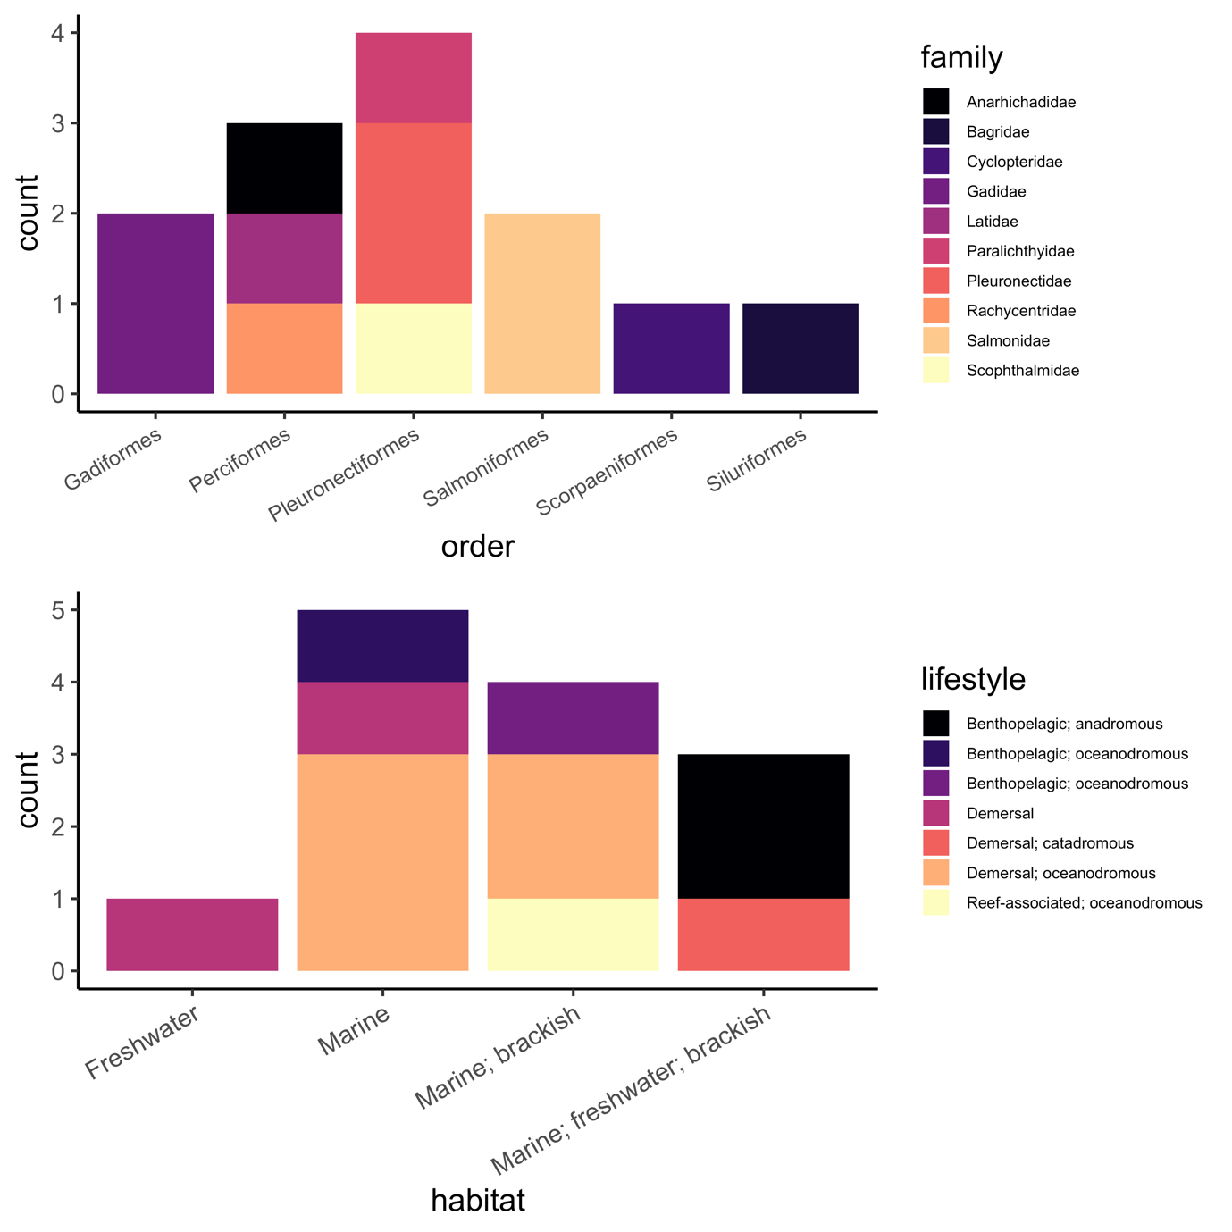

Fig. S1. Taxonomic representation (top) (order and family, the latter indicated by colour) and the lifestyle (indicated by colour) and habitat (bottom) of species represented in the growth rate data.

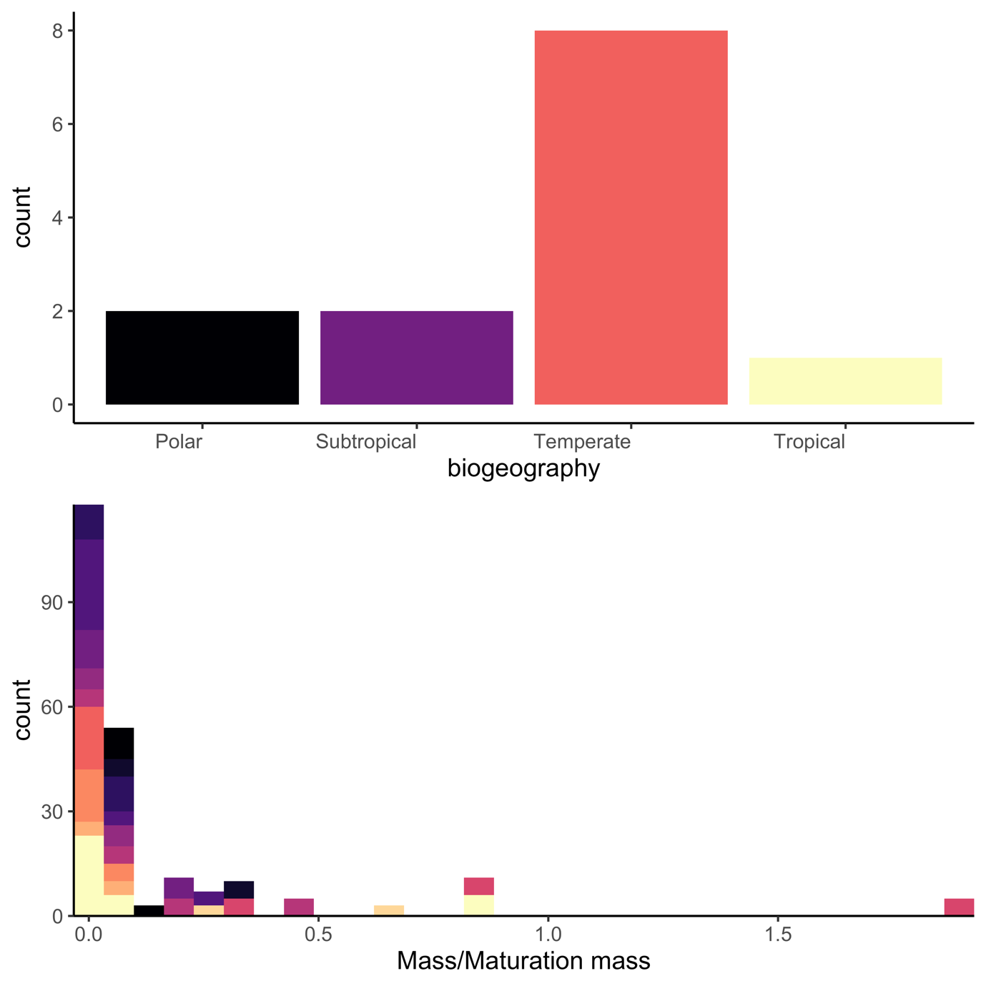

Fig. S2. Biogeography of species (top) and range of rescaled masses (mass/mass at maturation) of species represented in the growth rate data.

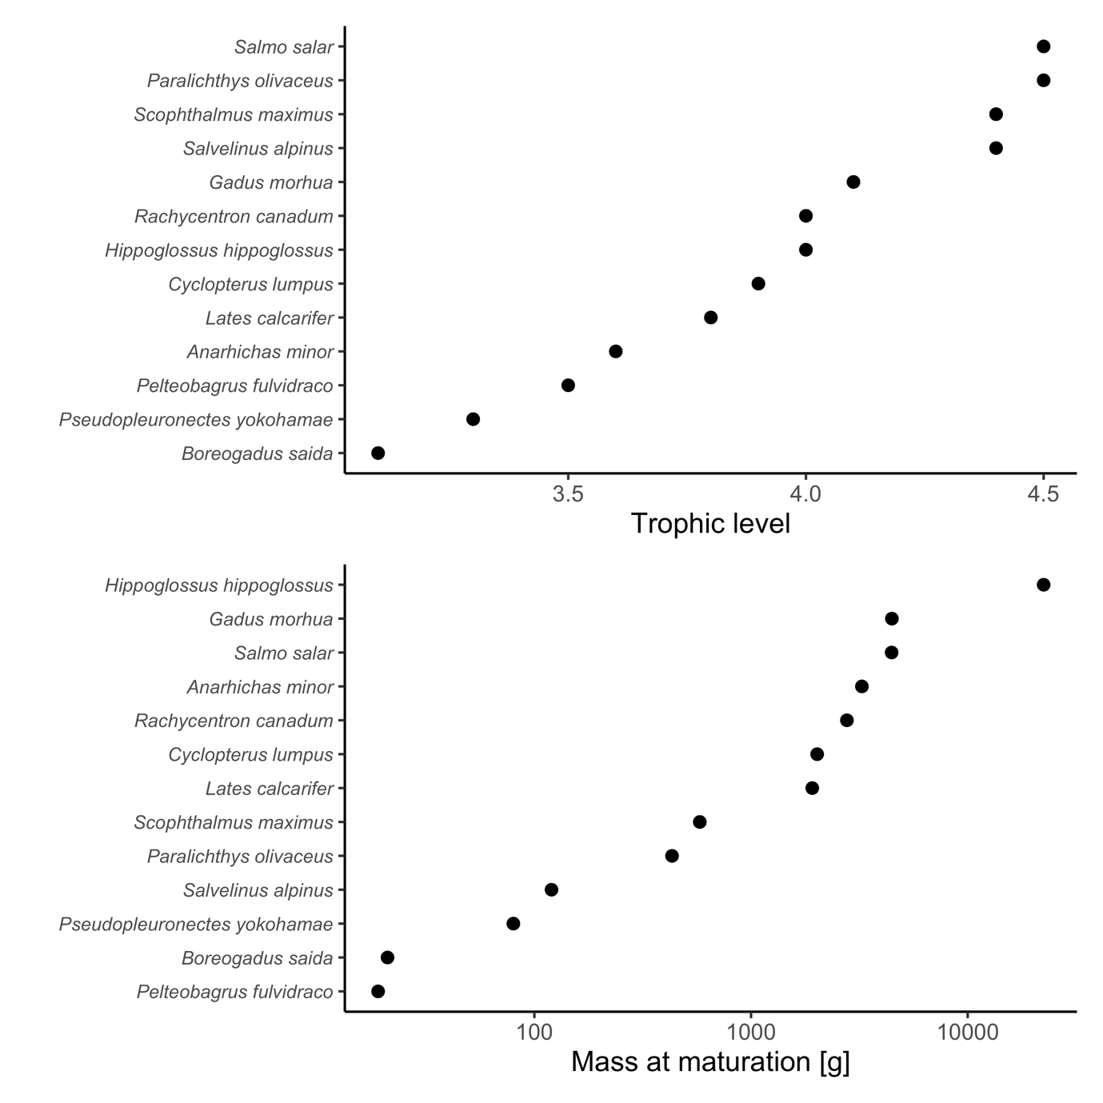

Fig. S3. Trophic level (top) and mass at maturation (bottom) of species represented in the growth rate data.

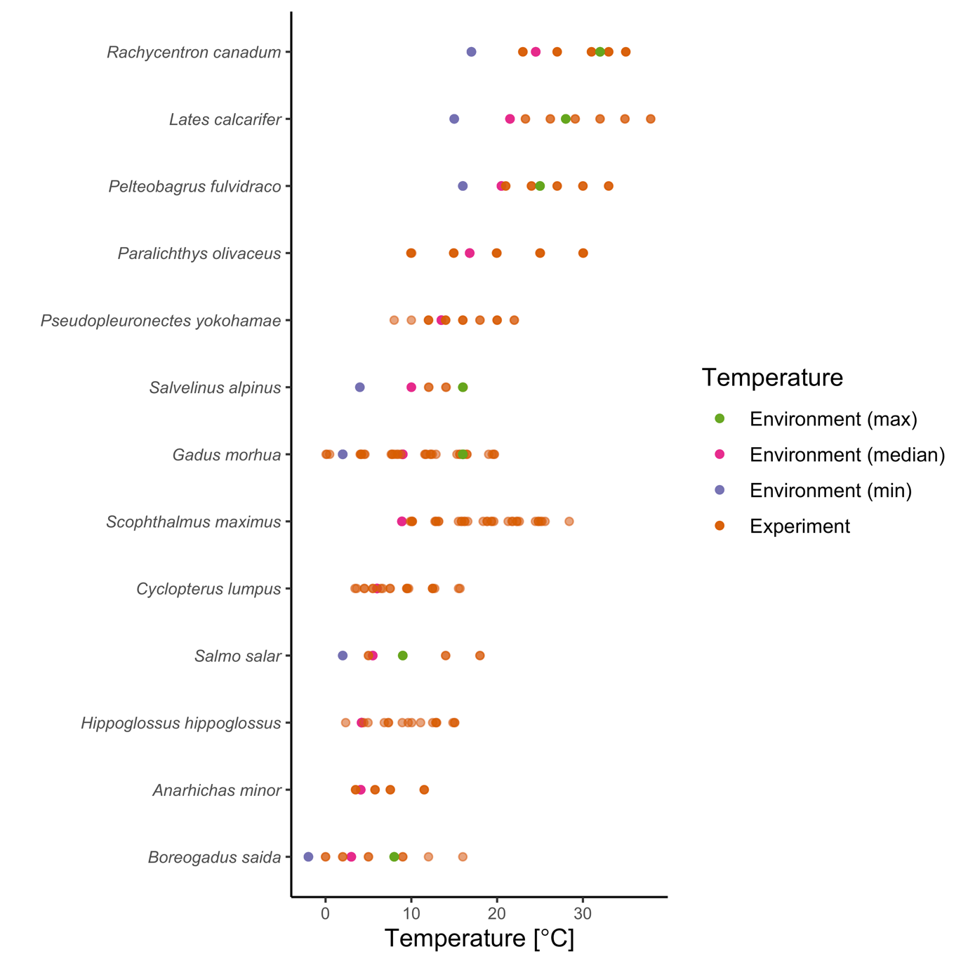

Fig. S4. Experimental and environmental (min, median and max) temperatures (indicated by colours) in the growth rate data.

## *Maximum consumption & metabolic rate*

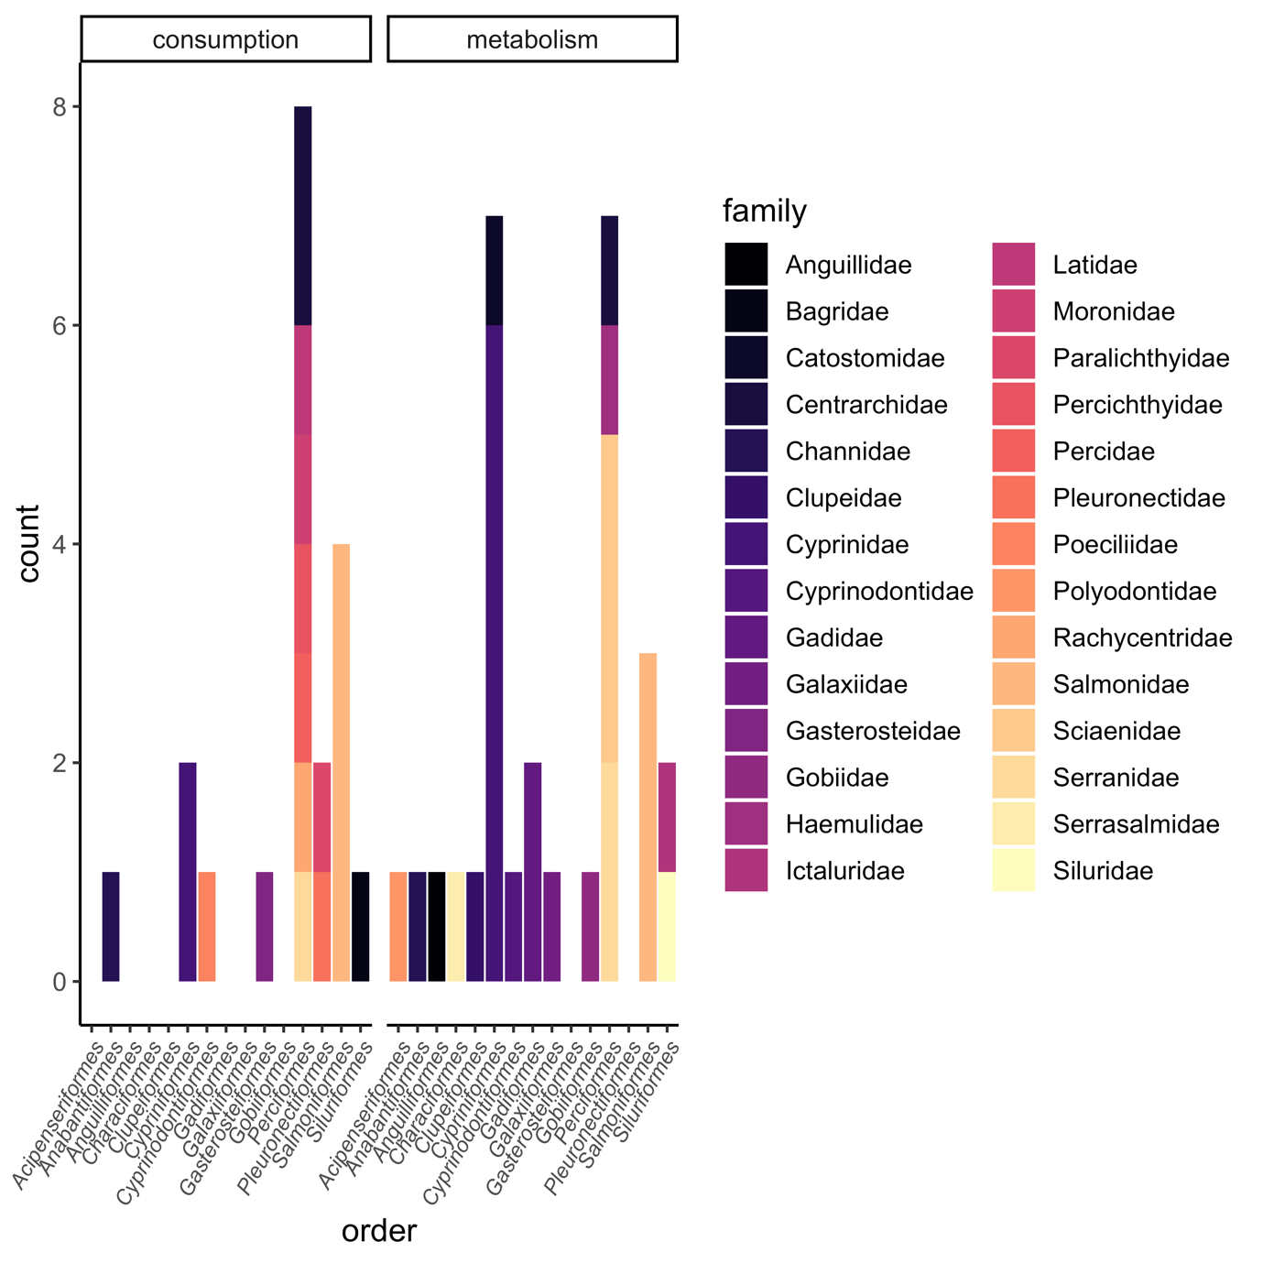

Fig. S5. Taxonomic information (order and family, latter indicated by colour) of species represented in the consumption (left) and metabolism (right) data sets.

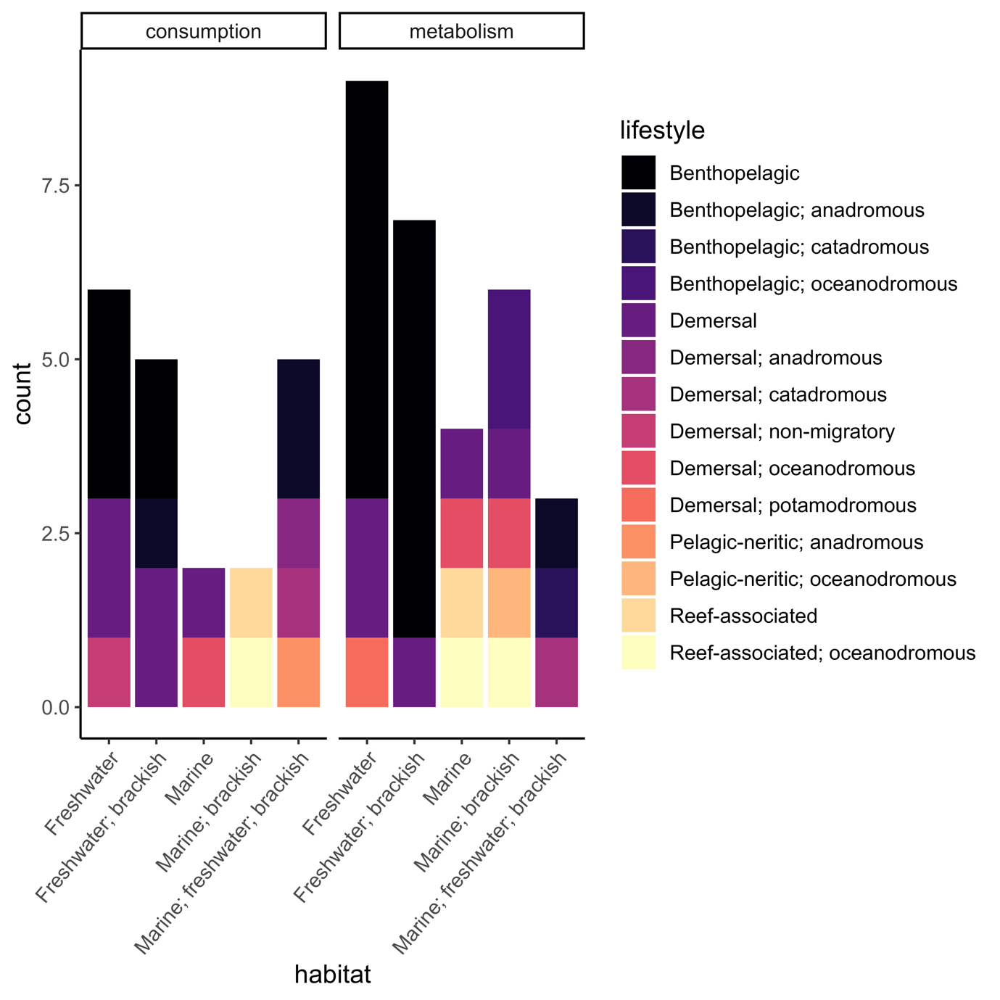

Fig. S6. Lifestyle and habitat (indicated by colour) of species represented in the consumption (left) and metabolism (right) data sets.

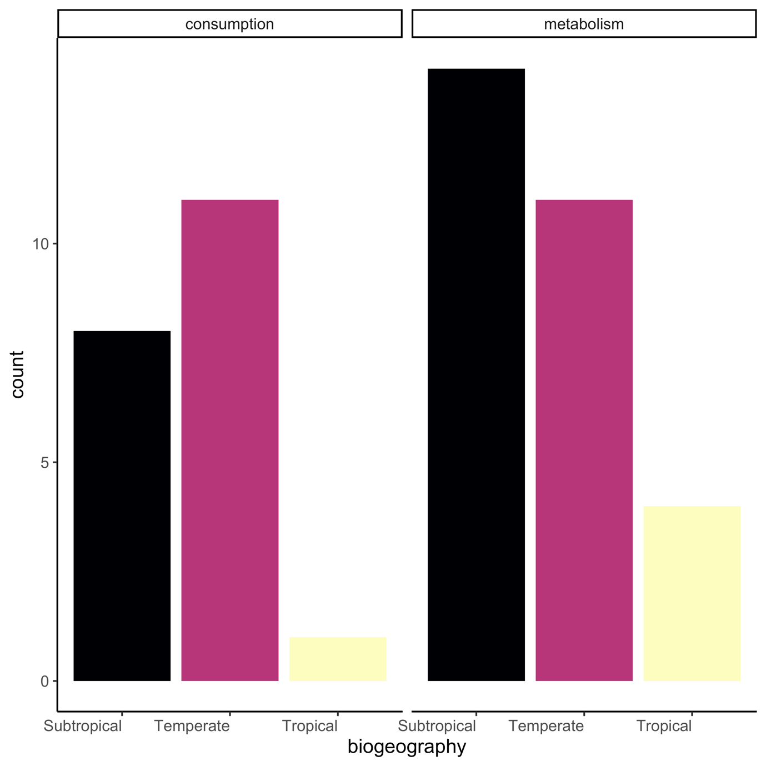

Fig. S7. Biogeography of species represented in the consumption (left) and metabolism (right) data sets.

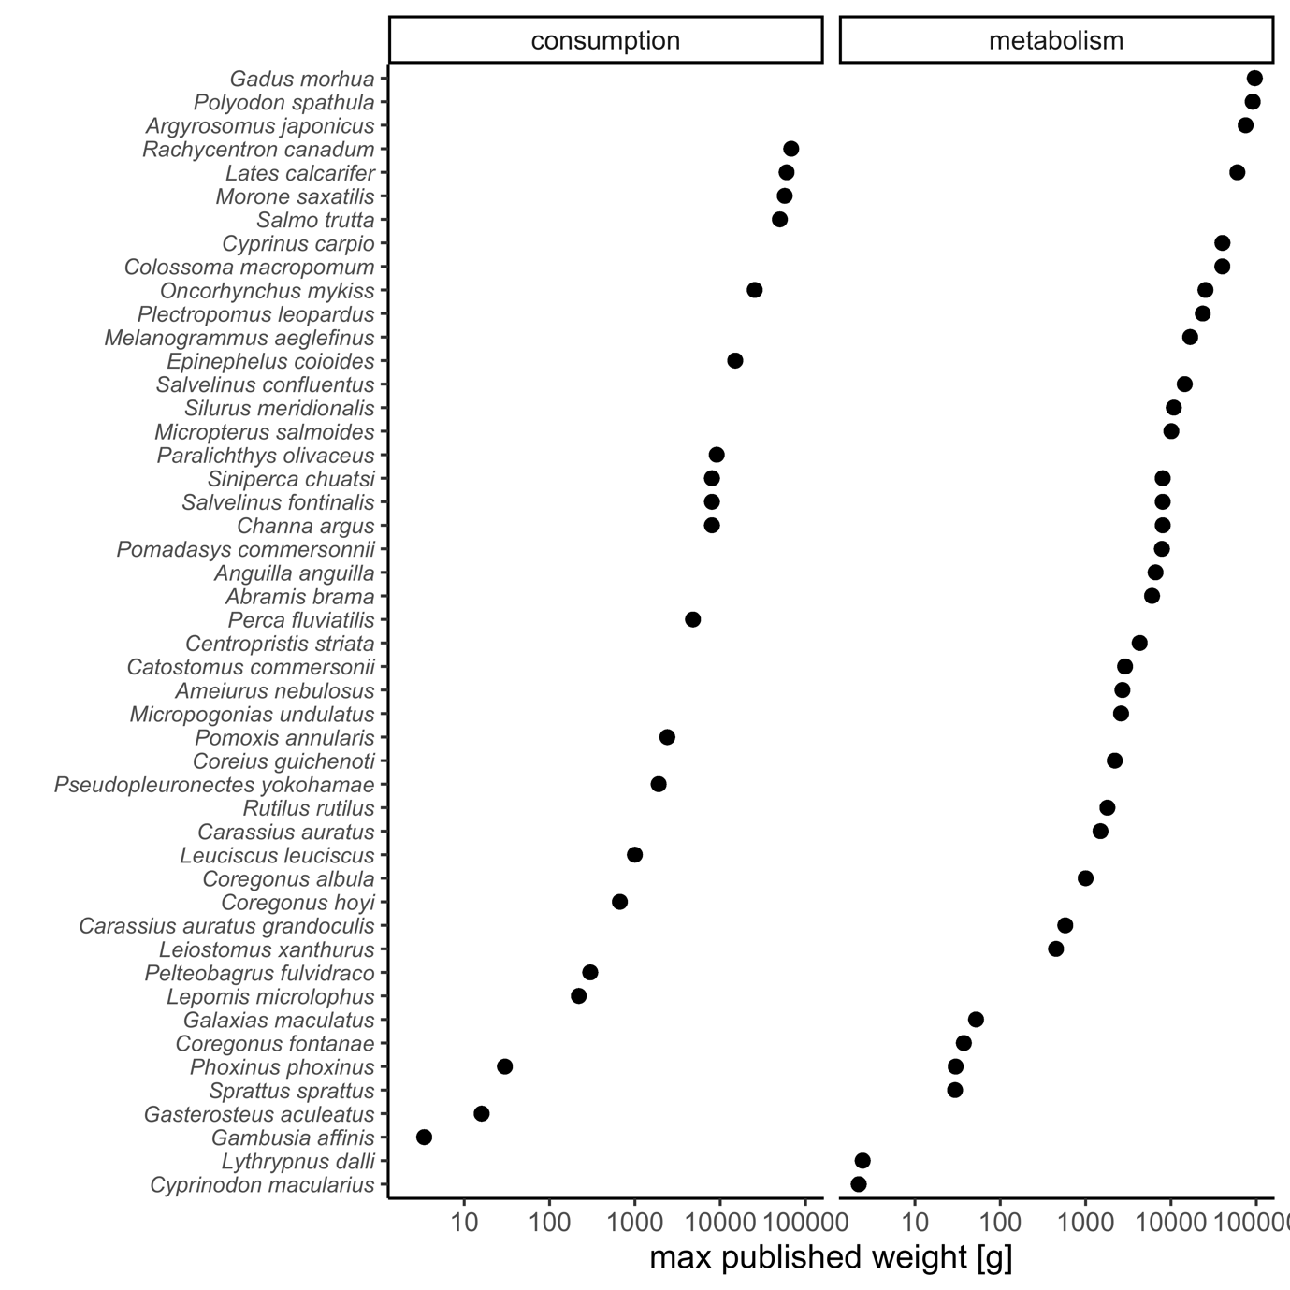

Fig. S8. Distribution of maximum body masses of species represented in the consumption (left) and metabolism (right) data sets.

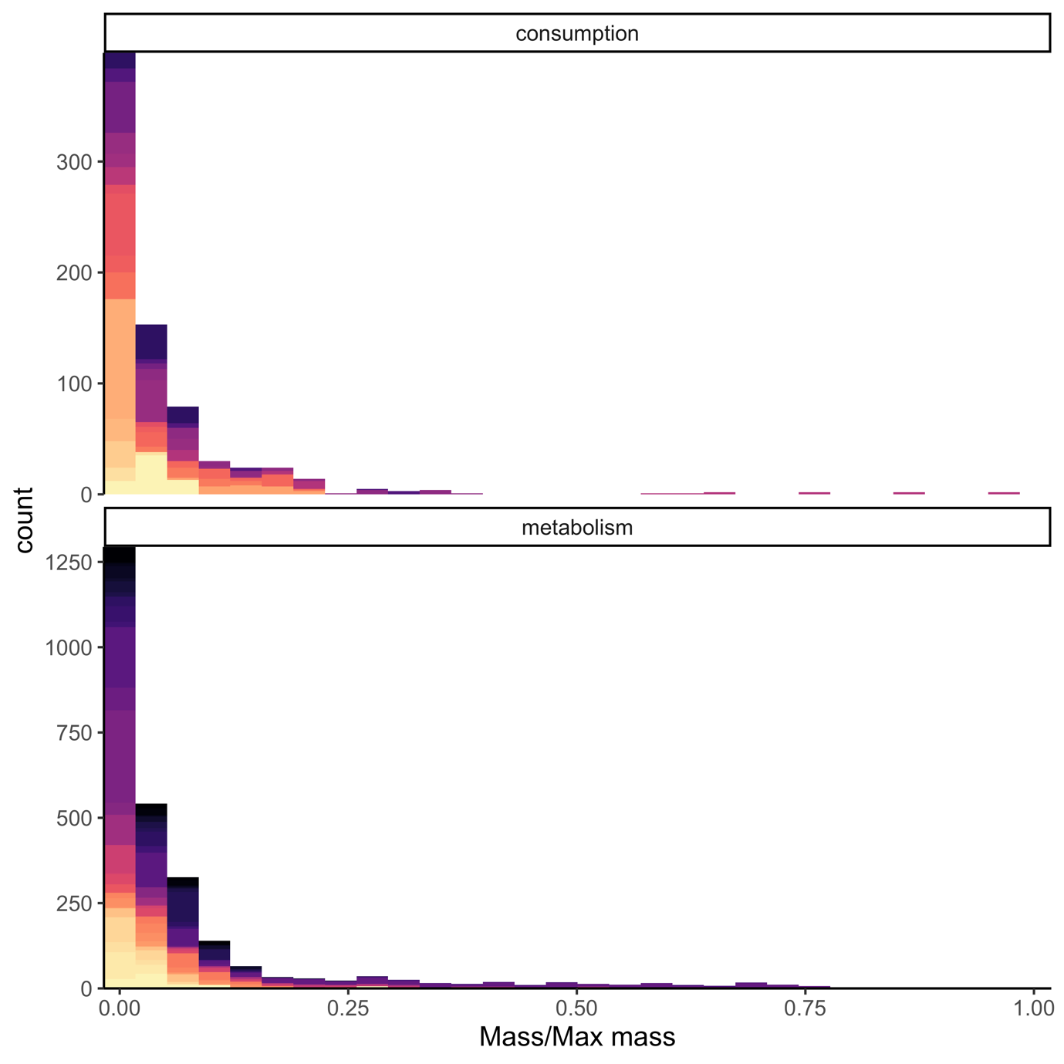

Fig. S9. Distribution of body masses of species represented in the consumption (top) and metabolism (bottom) data sets, expressed as relative to maximum mass of the species. Colours indicate species (legend not shown).

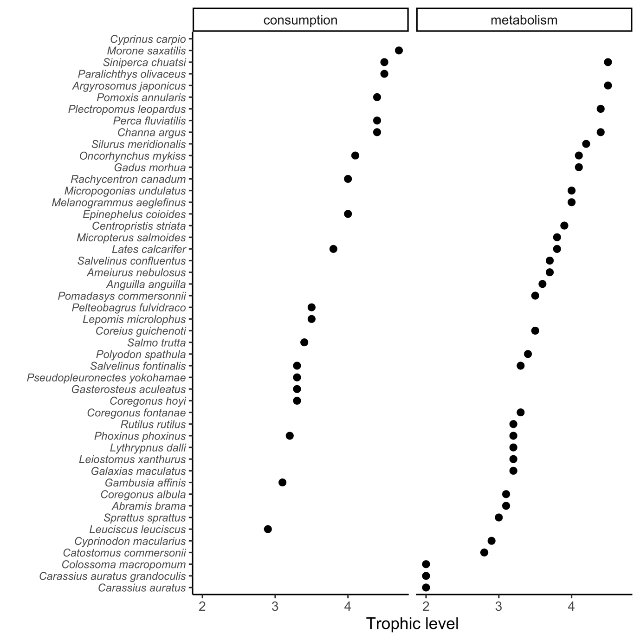

Fig. S10. Trophic level of species represented in the consumption (left) and metabolism (right) data sets.

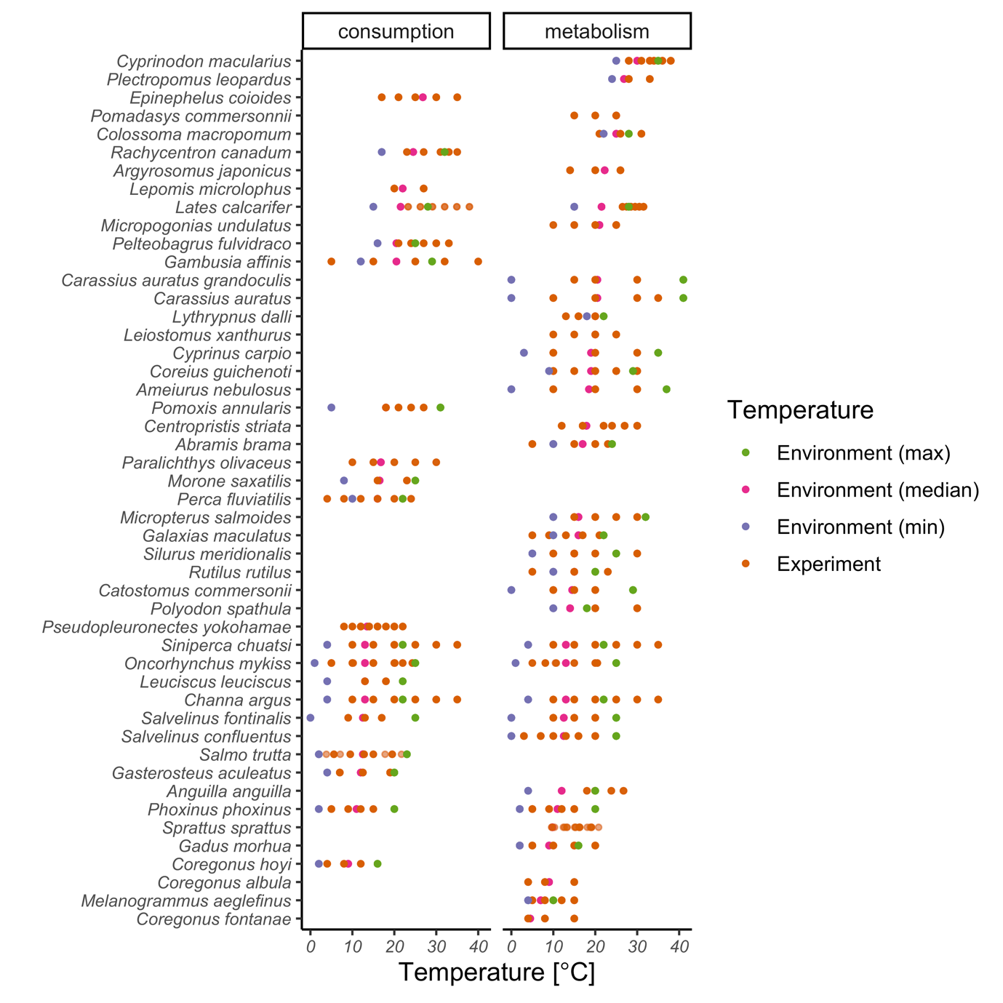

Fig. S11. Experimental and environmental (min, median and max) temperatures (indicated by colours) of species represented in the consumption (left) and metabolism (right) data sets.

# Supplementary analysis

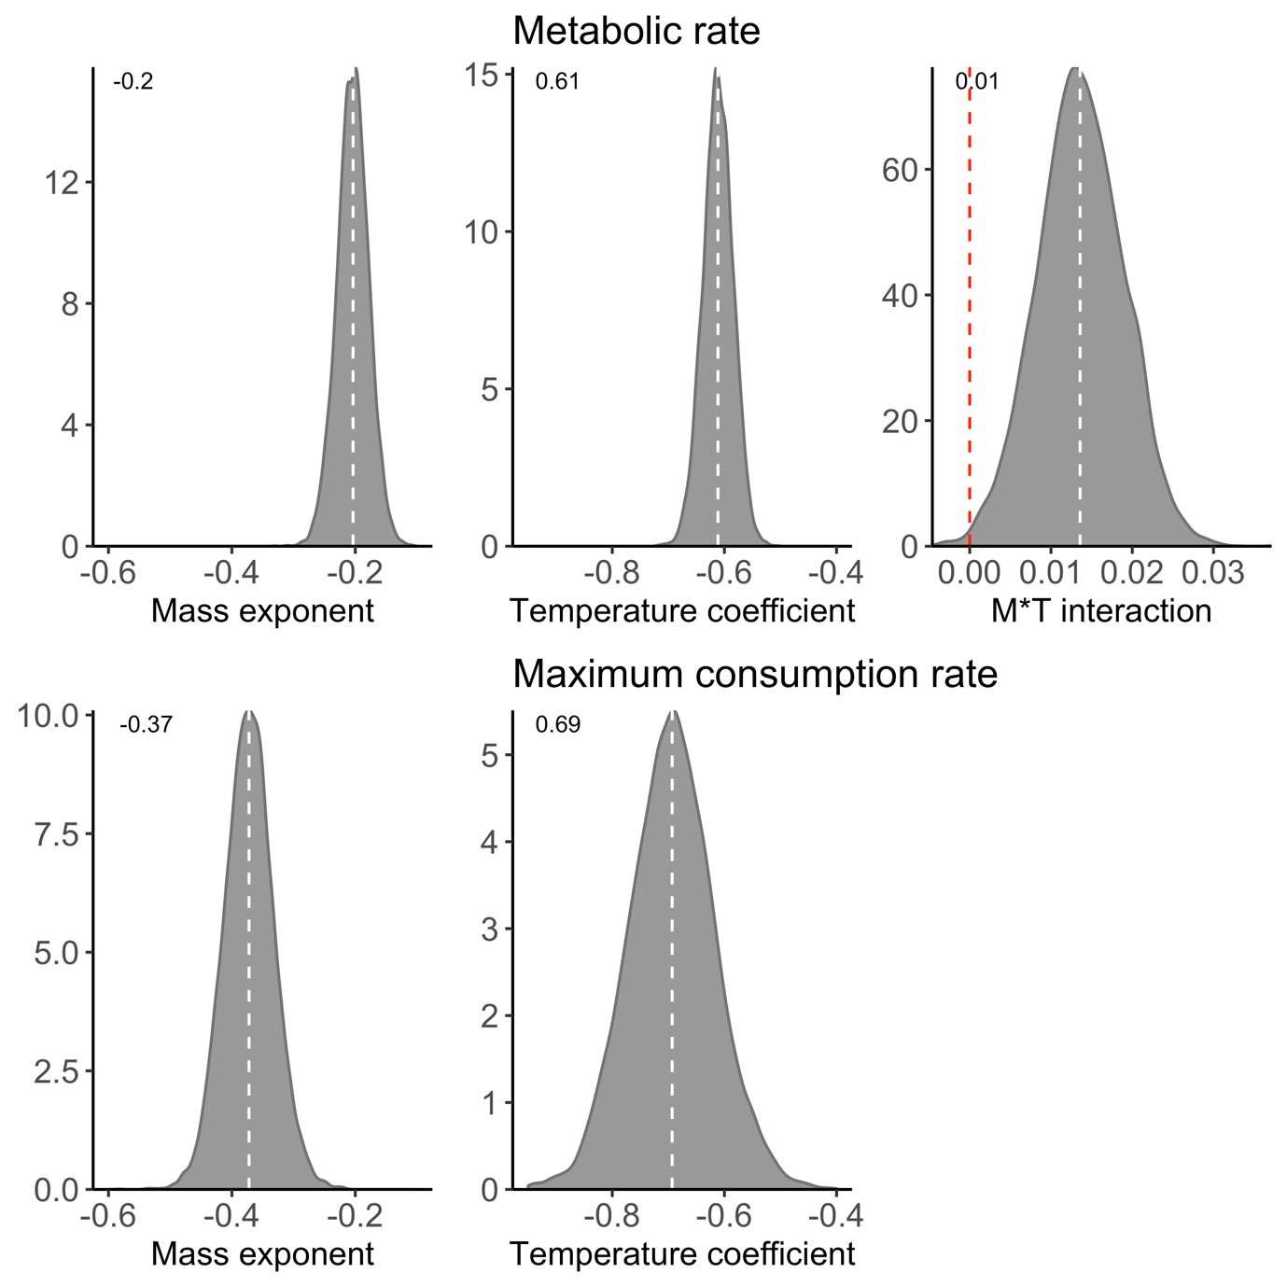

Fig. S12. Posterior distributions of the global intraspecific mass-specific mass exponents ($μ_{β_{1}}$) and temperature coefficients ($μ_{β_{2}}$) for metabolic rate (top) and maximum consumption rate (bottom). For metabolism, the global interaction coefficient ($β_{3}$) is also shown (estimated and presented on an Arrhenius temperature scale), but for consumption this term was not included in the selected model. Numbers in the top left corner correspond to the posterior median. The axes are the same for each parameter for comparison between the two rates.

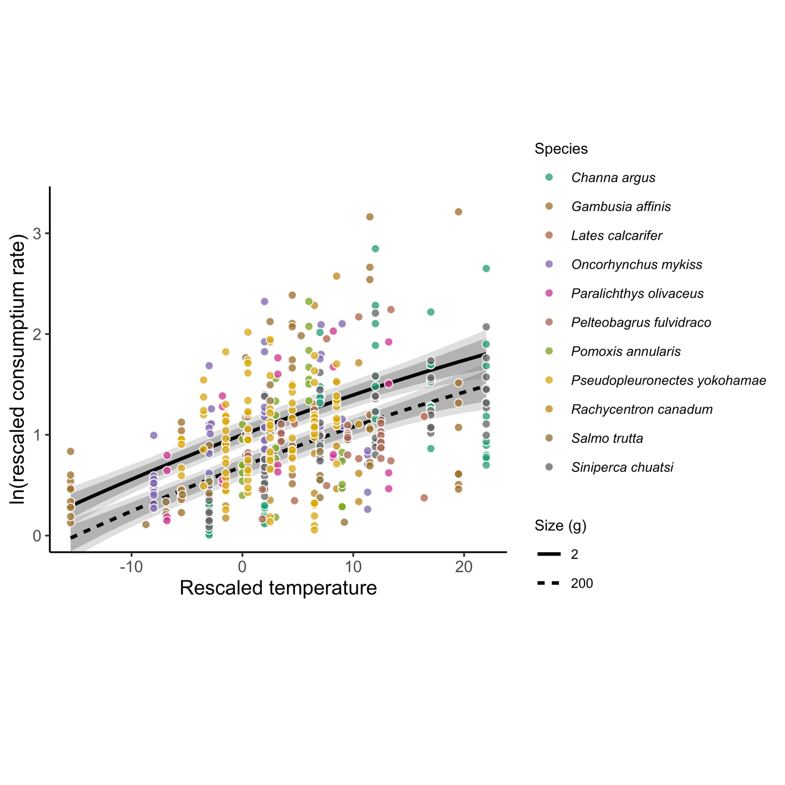

Fig. S13. Maximum consumption rates expressed as relative to maximum consumption rates (done by species) for species with data beyond peak temperatures plotted against temperature, expressed as the difference between the experimental temperature and the median environmental temperature (also by species species). Lines show fits from polynomial model using the posterior medians of the average intercept across species and the common coefficients, grey bands show 95% and 80% credible intervals. Colors indicate species.

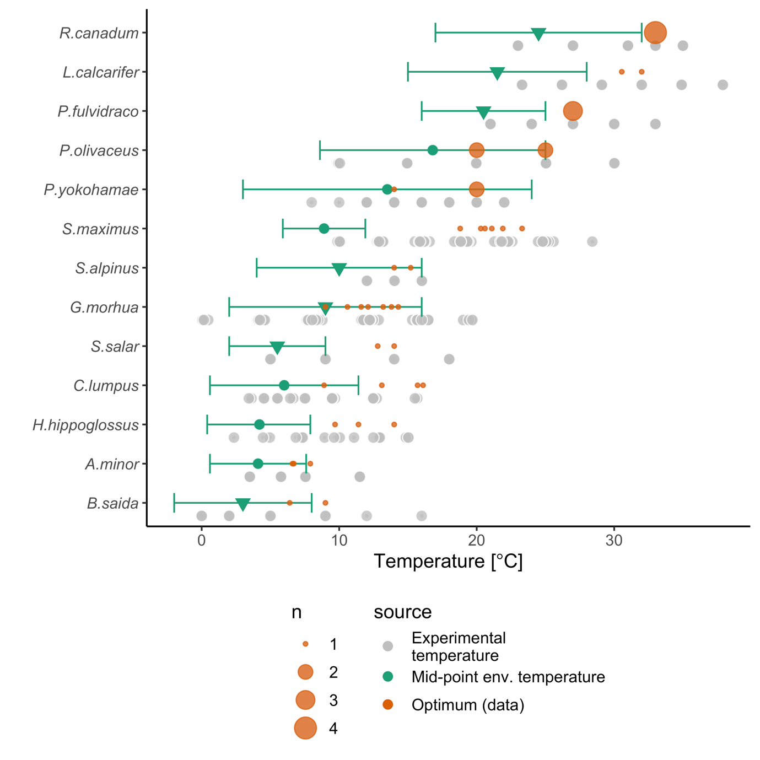

*Fig. S14. Experimental temperatures (grey) overlap environmental temperatures (green), and optimum growth temperatures (orange) are typically at the upper end or above the environmental range. Horizontal green lines show the minimum and maximum environmental temperature based on either temperature in distribution range (triangles) or modelled distribution maps (circles), both taken from FishBase. The optimum growth temperatures are depicted for all size-classes per species, where the circle size is proportional to number of observations at that temperature.*

# Model validation and fit

Figures showing convergence of species-level parameters can be found on: <https://github.com/maxlindmark/scaling>, in this section only global parameters are visualized.

## *Growth rate*

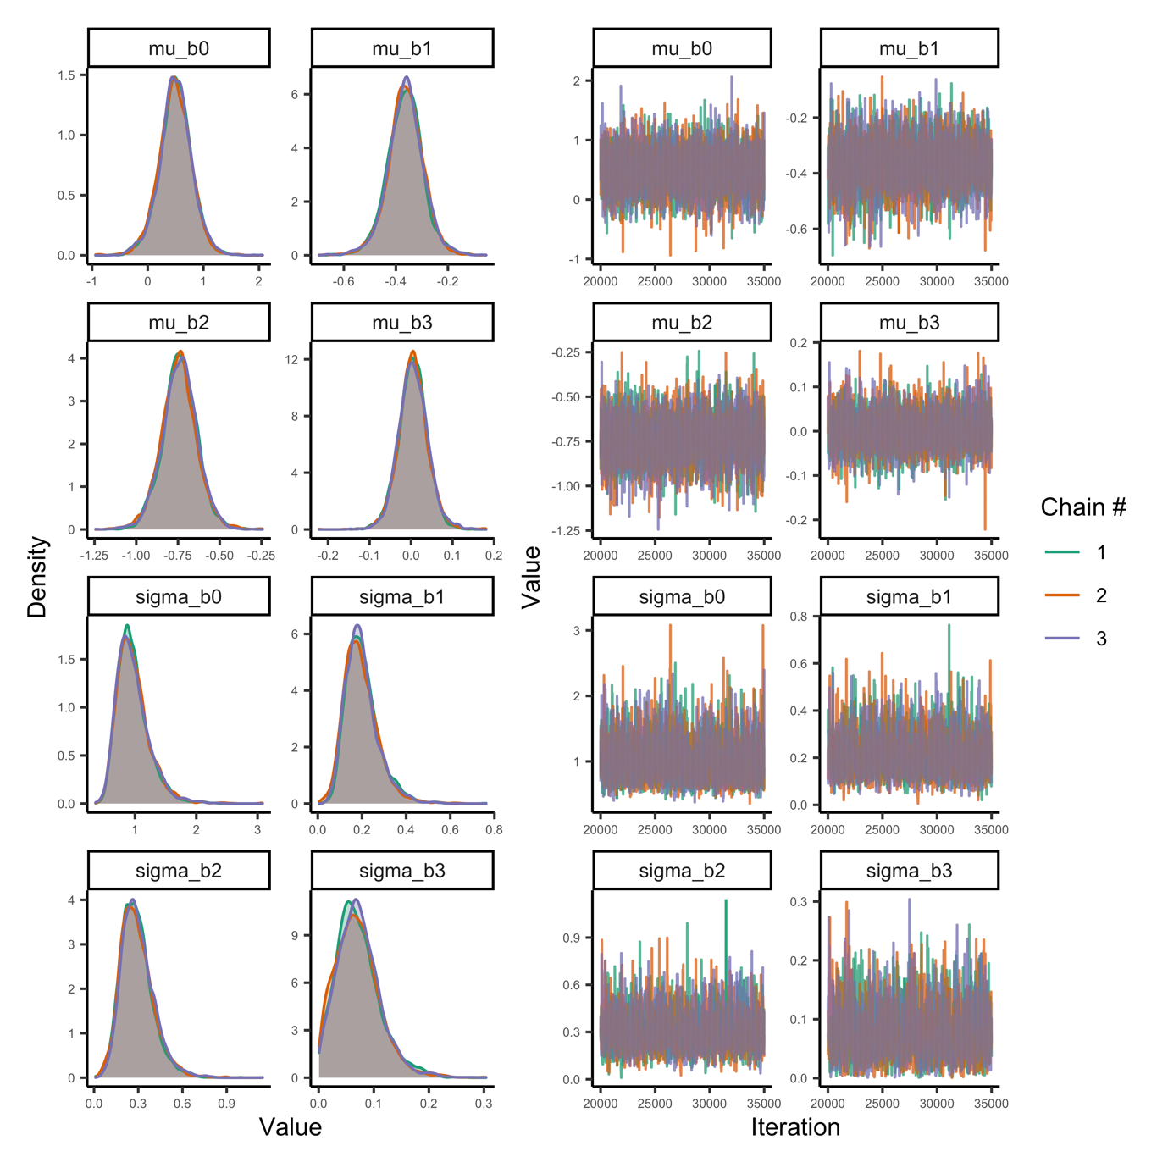

Fig. S15. Posterior densities and trace plots for evaluation of chain convergence (by chain, indicated by colour), for the global-level parameters for the growth rate model at temperatures below optimum temperatures.

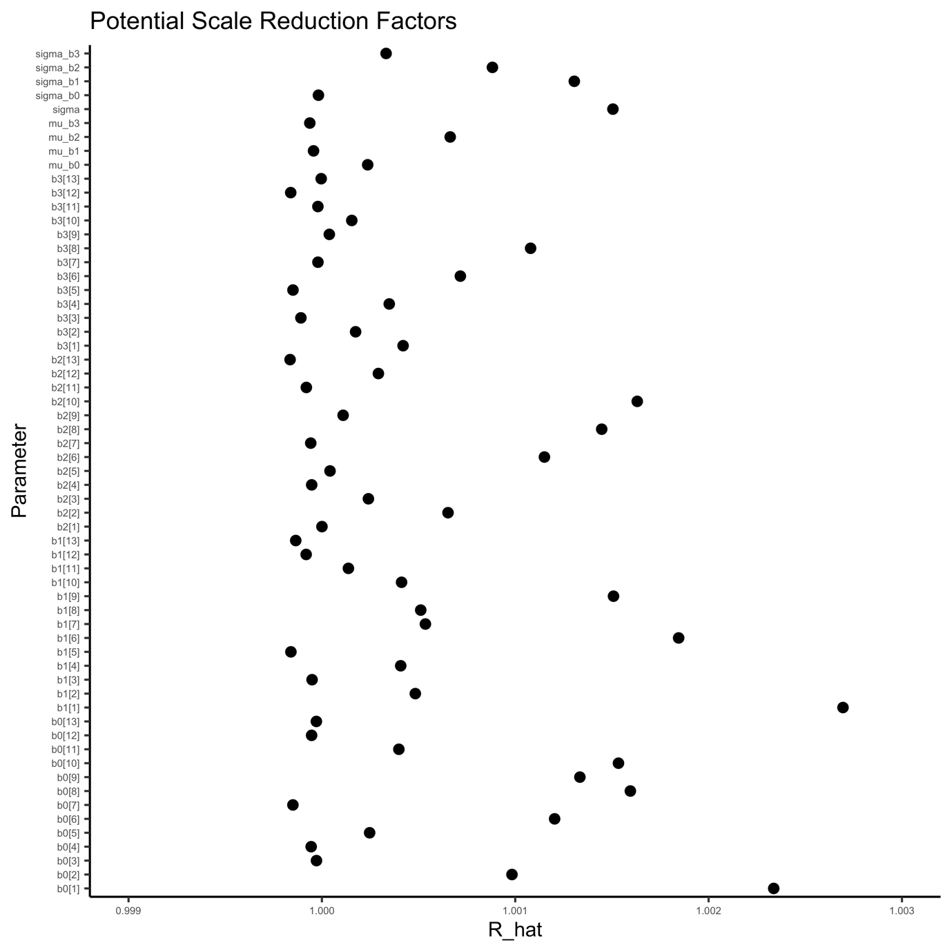

Fig. S16. Potential scale reduction factor ($\hat{R}$) for the growth rate model. This factor is based on the comparison of between and within-chain variation for the same parameter. A value close to one implies chains converged to the same distribution. The index of the parameter corresponds to species.

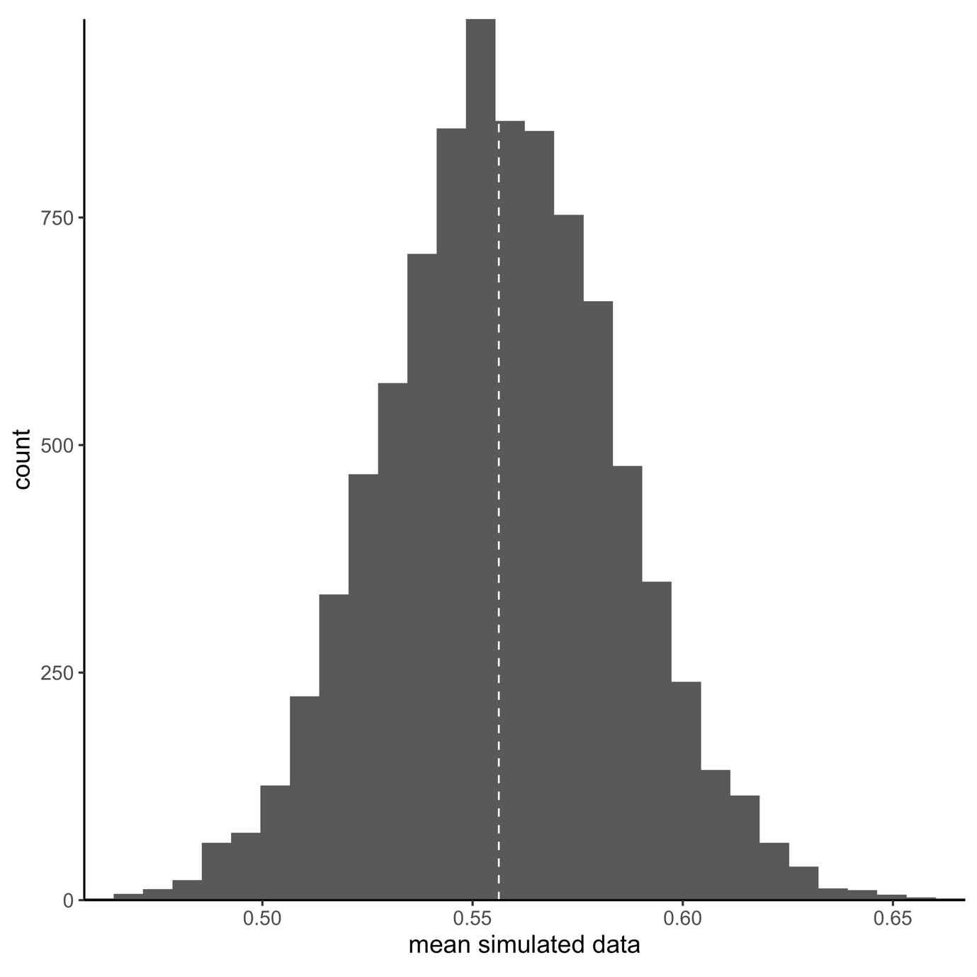

Fig. S17. Model fit (A=mean and B=coefficient of variation) for the model of growth at temperatures below temperature optima. Vertical lines correspond to mean in data and histogram depicts each posterior mean. Fit is evaluated by simulating data from the likelihood (at each iteration of the MCMC chain), to compare how well it matches the original data. Each simulated datum is assigned a 0 or 1 if it is below or above the mean data point. The number in the plot corresponds to the mean of the vector of 0’s and 1’s.

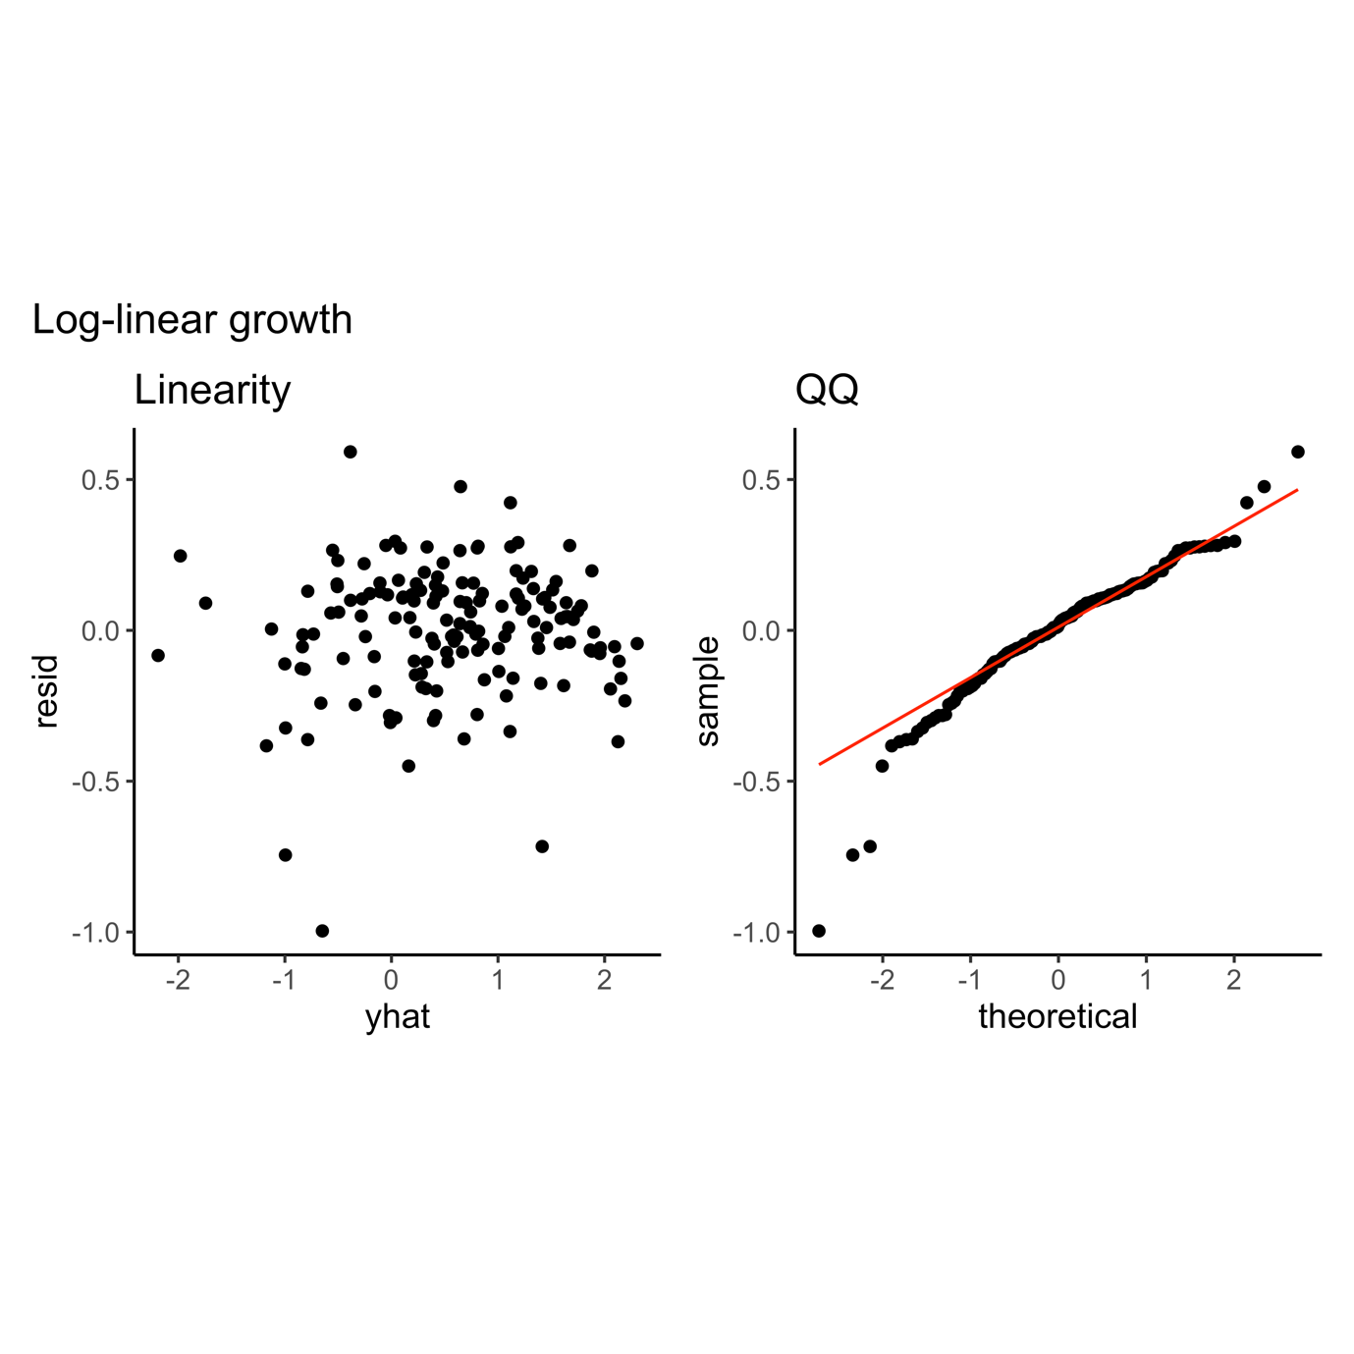

Fig. S33.

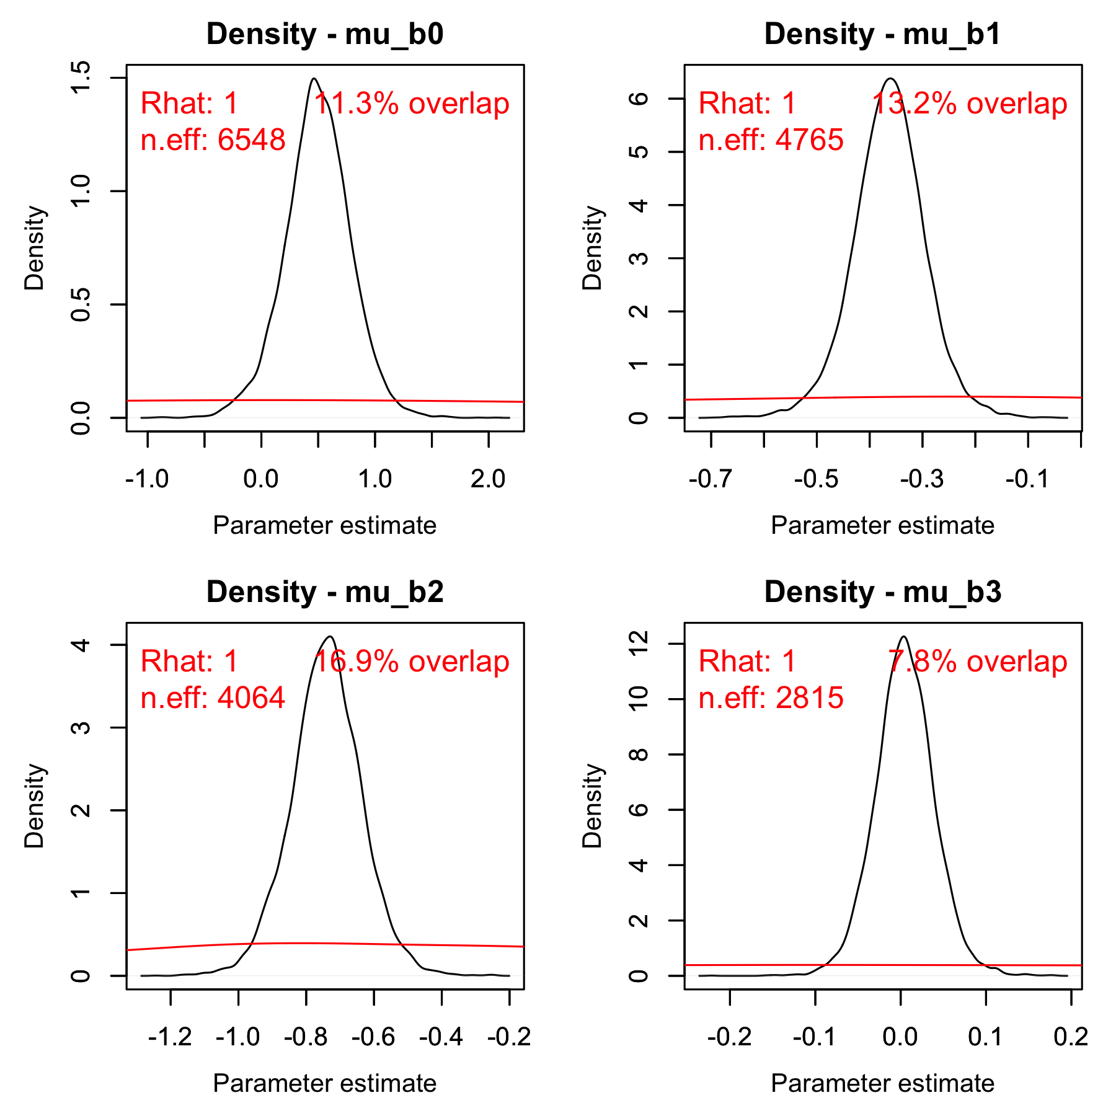

Fig. S18. Posterior (black) and prior distribution (red) for the global parameters in the model for growth rate, including their % overlap, effective sample size and $\hat{R}$ (rounded).

## *Maximum consumption rate – below peak temperatures*

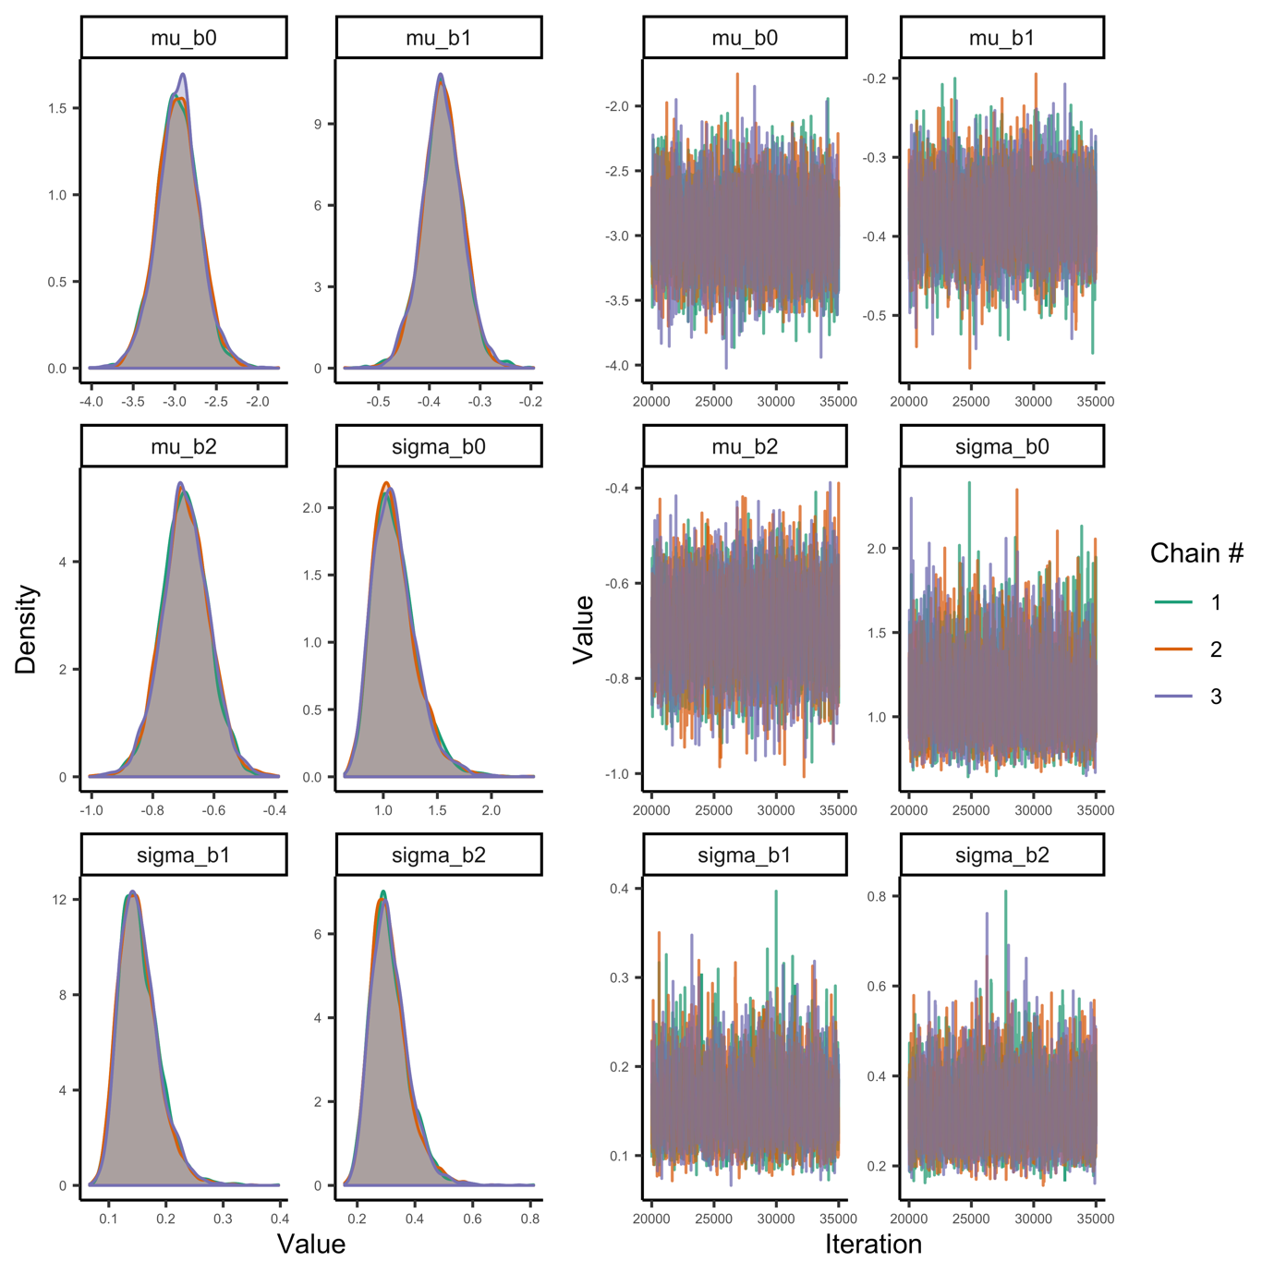

Fig. S19. Posterior densities and trace plots for evaluation of chain convergence (by chain, indicated by colour), for the global-level parameters for the maximum consumption rate model at temperatures below optimum temperatures.

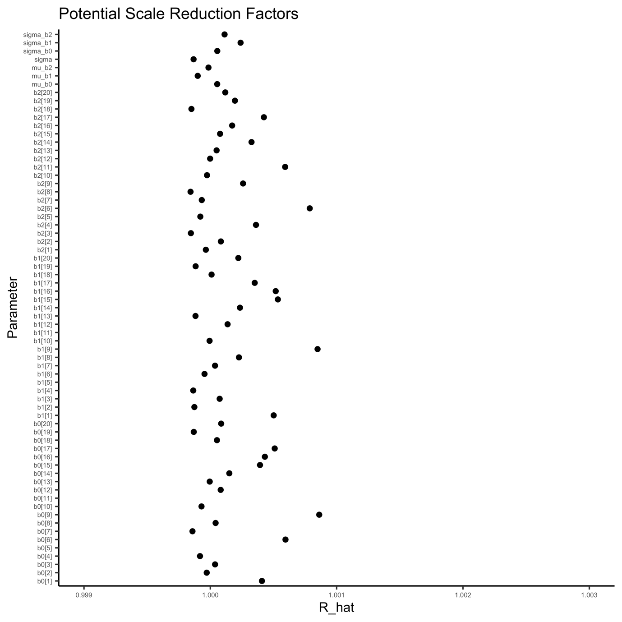

Fig. S20. Potential scale reduction factor ($\hat{R}$) for the maximum consumption rate model. This factor is based on the comparison of between and within-chain variation for the same parameter. A value close to one implies chains converged to the same distribution. The index of the parameter corresponds to species.

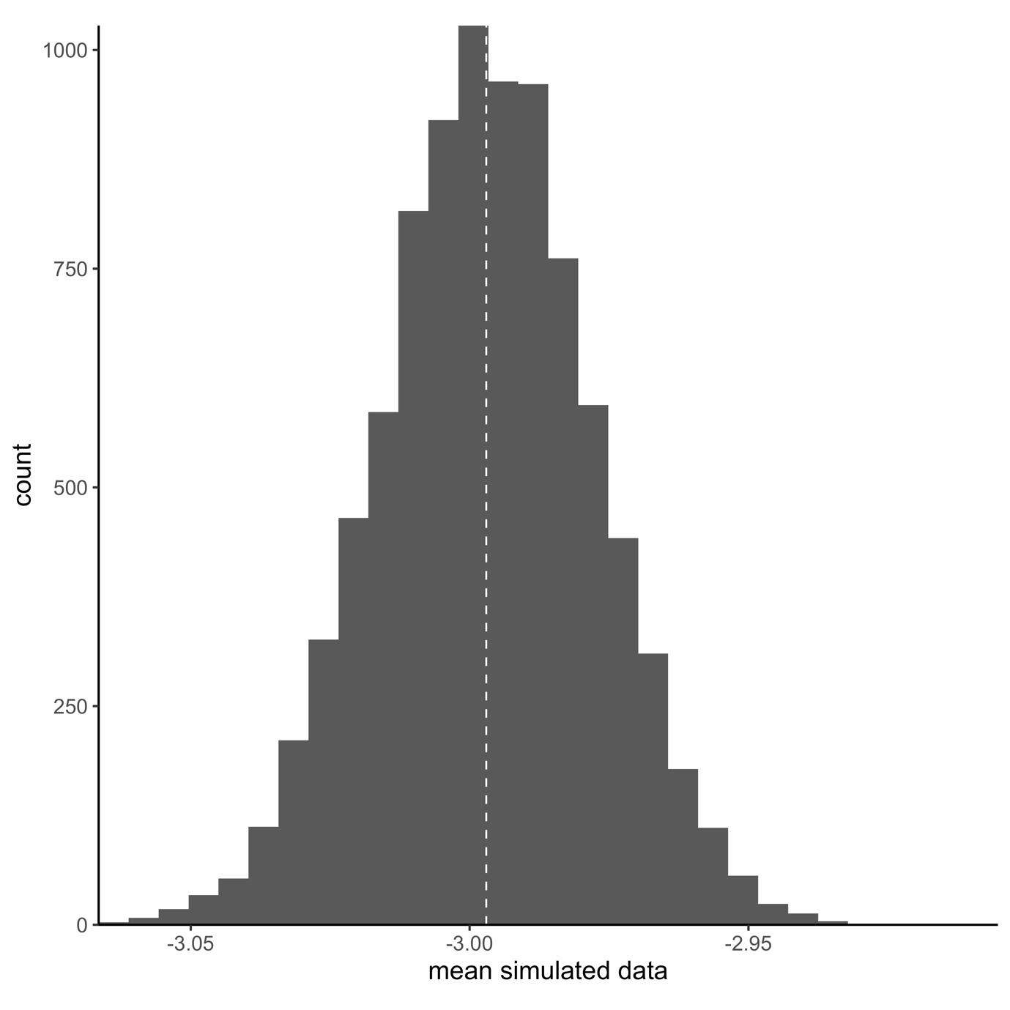

Fig. S21. Model fit (A=mean and B=coefficient of variation) for the model of maximum consumption rate at temperatures below temperature optima. Vertical lines correspond to mean in data and histogram depicts each posterior mean. Fit is evaluated by simulating data from the likelihood (at each iteration of the MCMC chain), to compare how well it matches the original data. Each simulated datum is assigned a 0 or 1 if it is below or above the mean data point. The number in the plot corresponds to the mean of the vector of 0’s and 1’s.

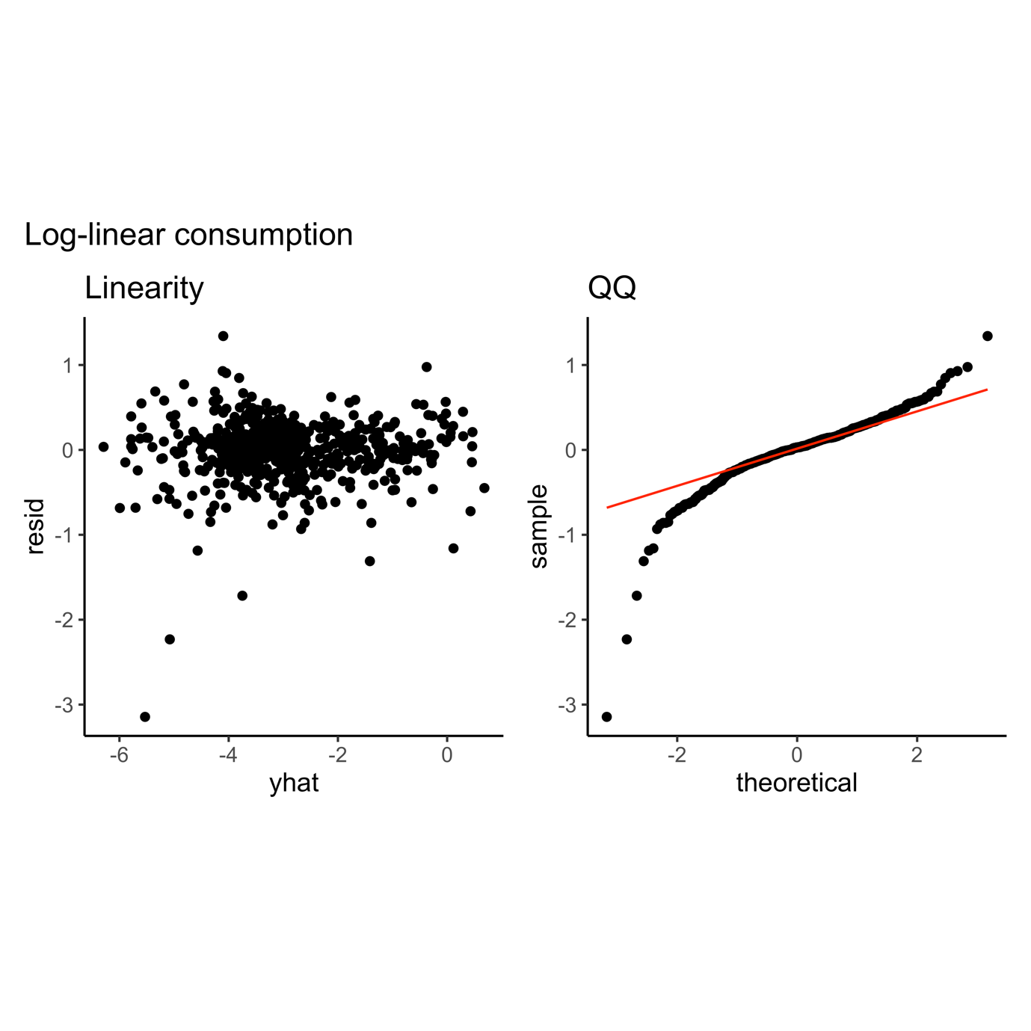

Fig. S33.

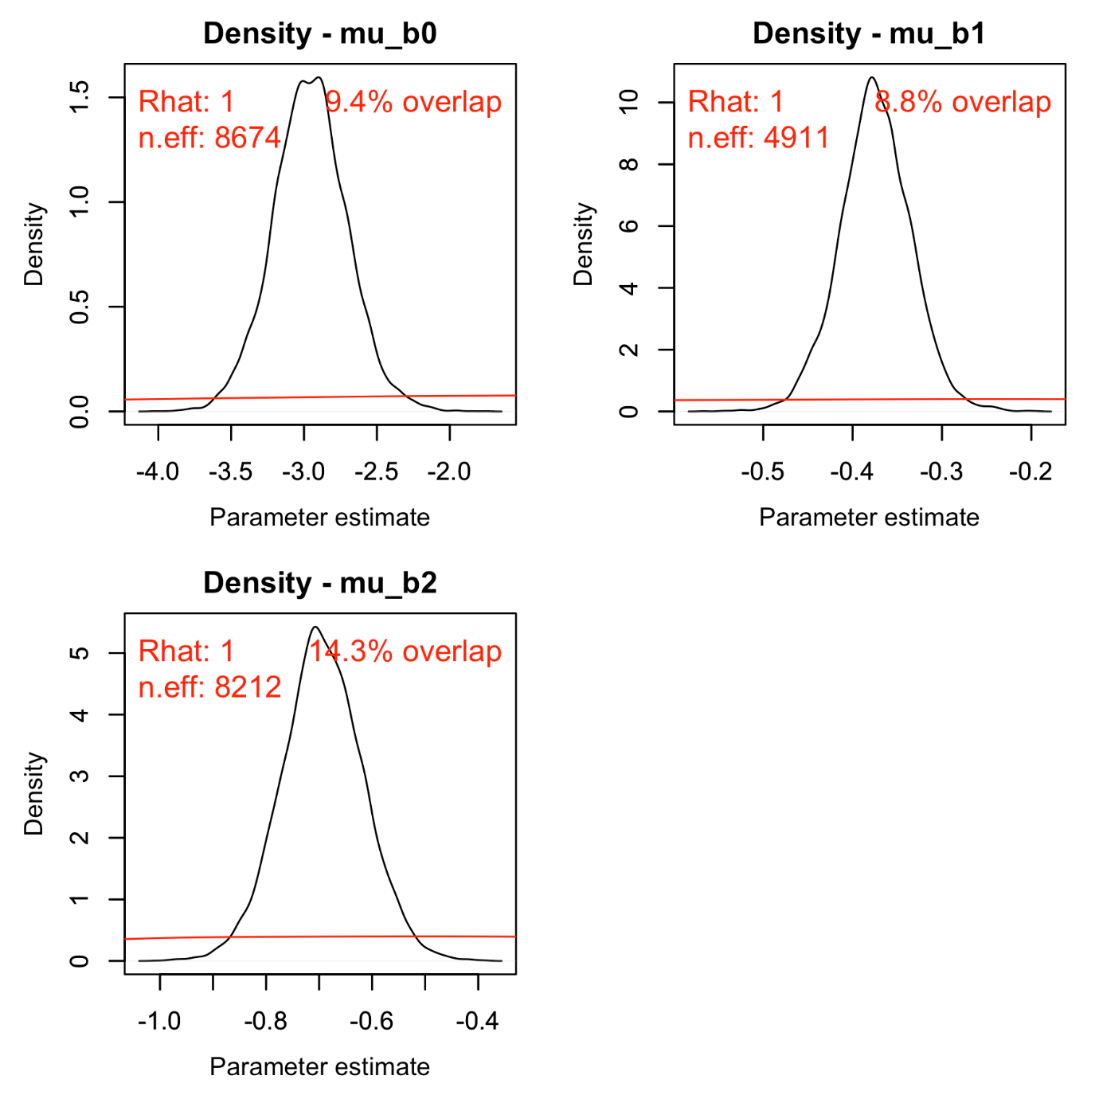

Fig. S22. Posterior (black) and prior distribution (red) for the global parameters in the model for maximum consumption rate, including their % overlap, effective sample size and $\hat{R}$ (rounded).

## *Maximum consumption rate – including beyond peak temperatures*

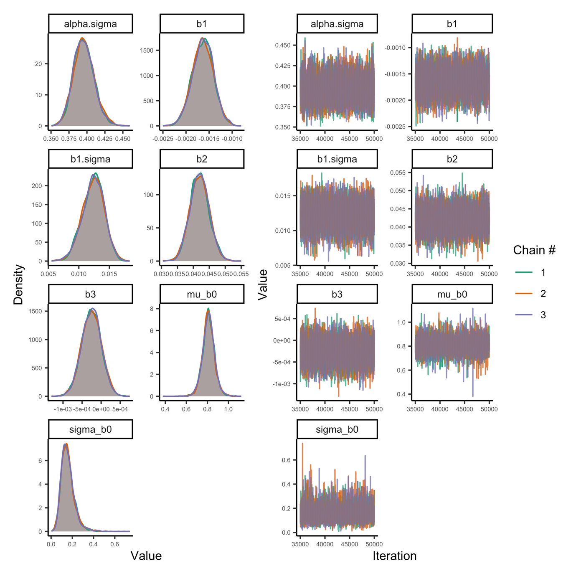

Fig. S23. Posterior densities and trace plots for evaluation of chain convergence (by chain, indicated by colour), for the global-level parameters for the maximum consumption rate model with temperatures including beyond peak temperatures.

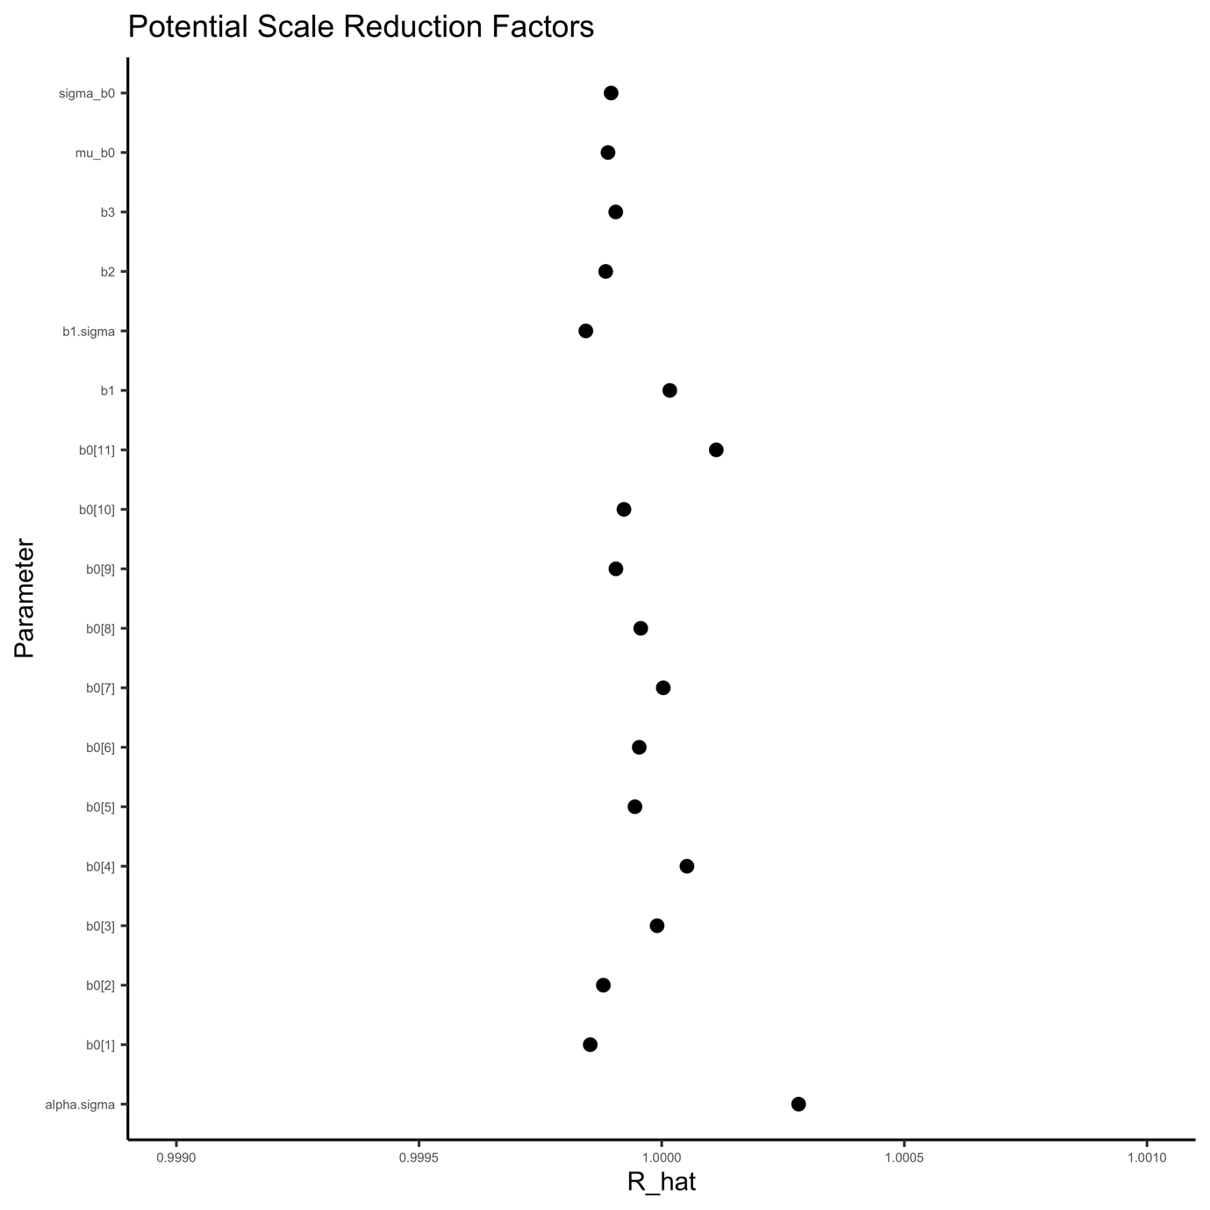

Fig. S24. Potential scale reduction factor () for the maximum consumption rate model (including data beyond peak). This factor is based on the comparison of between and within-chain variation for the same parameter. A value close to one implies chains converged to the same distribution. The index of the parameter corresponds to species.

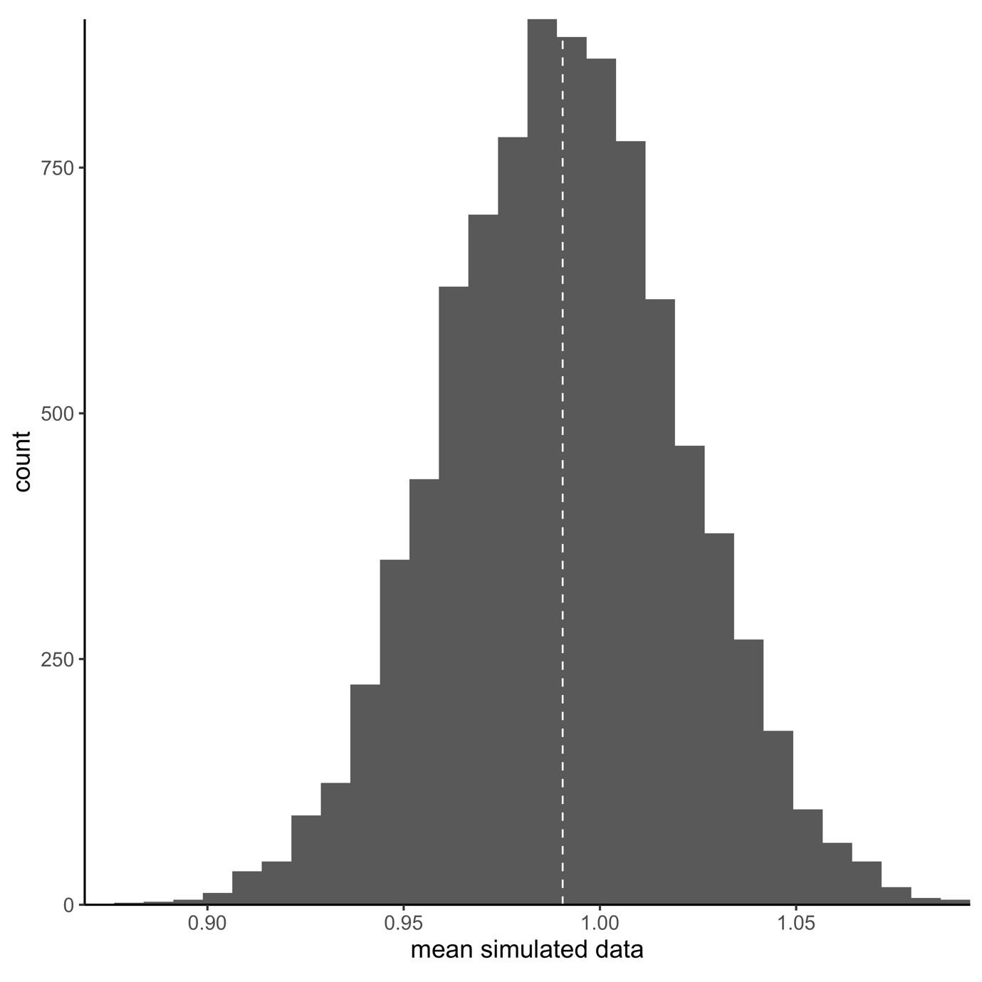

Fig. S25. Model fit (mean) for the model of maximum consumption rate at temperatures below temperature optima. Vertical lines correspond to mean in data and histogram depicts each posterior mean. Fit is evaluated by simulating data from the likelihood (at each iteration of the MCMC chain), to compare how well it matches the original data. Each simulated datum is assigned a 0 or 1 if it is below or above the mean data point. The number in the plot corresponds to the mean of the vector of 0’s and 1’s.

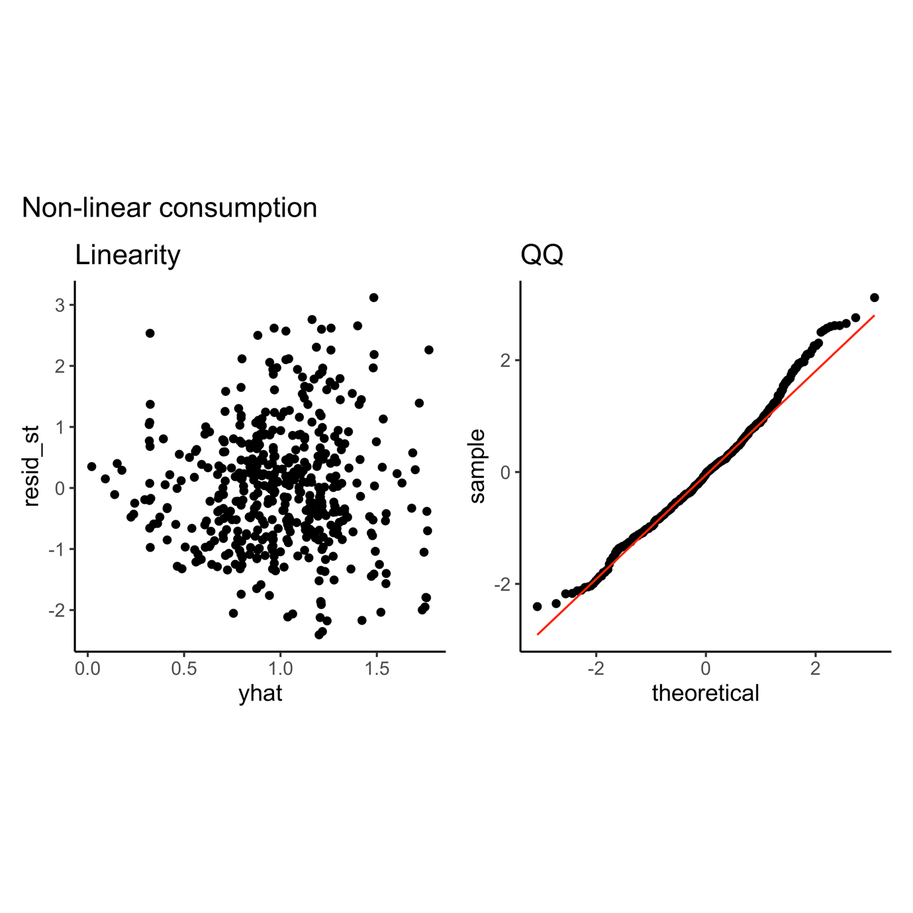

Fig. S33.

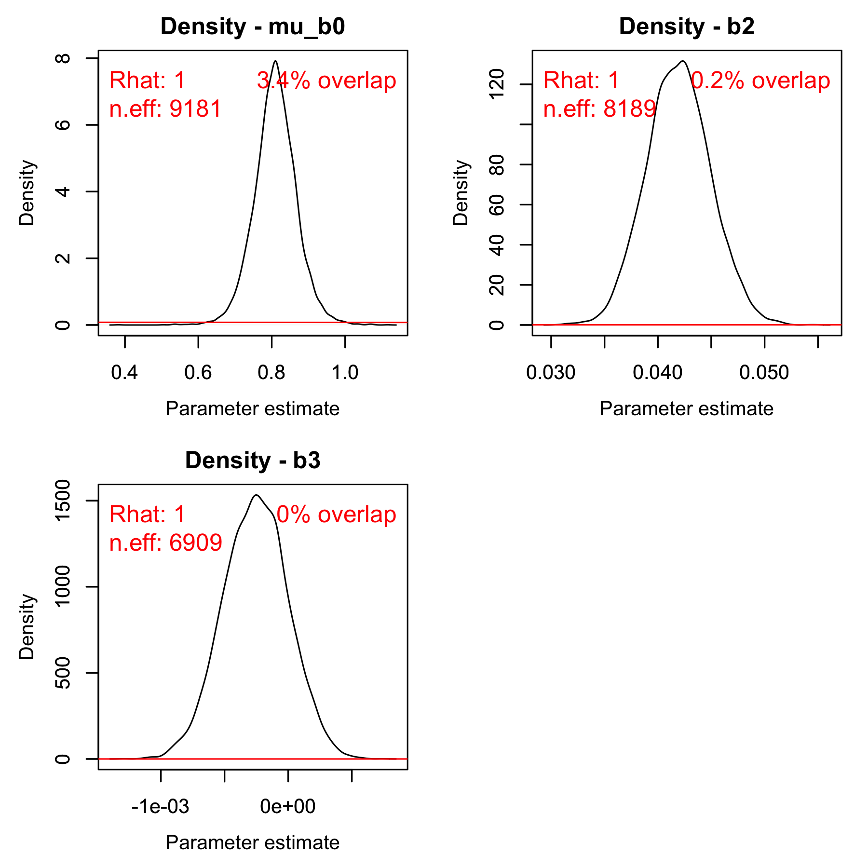

Fig. S26. Posterior (black) and prior distribution (red) for the global parameters in the model for maximum consumption rate including data beyond peak, including their % overlap, effective sample size and (rounded).

## *Metabolic rate*

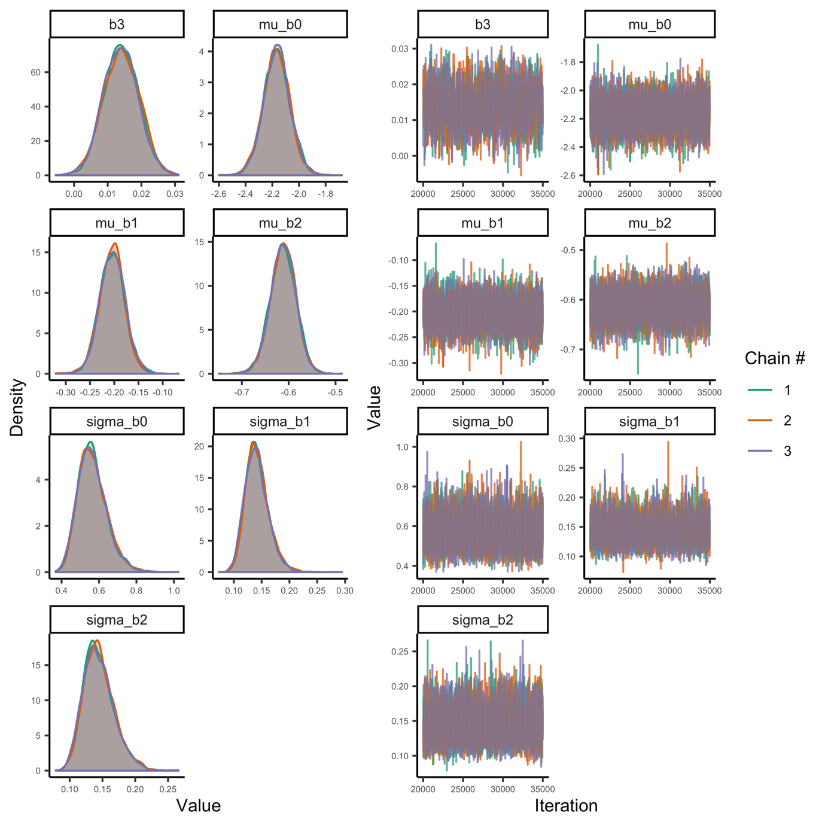

Fig. S27. Posterior densities and trace plots for evaluation of chain convergence (by chain, indicated by colour), for the global-level parameters for the metabolic rate model at temperatures below optimum temperatures.

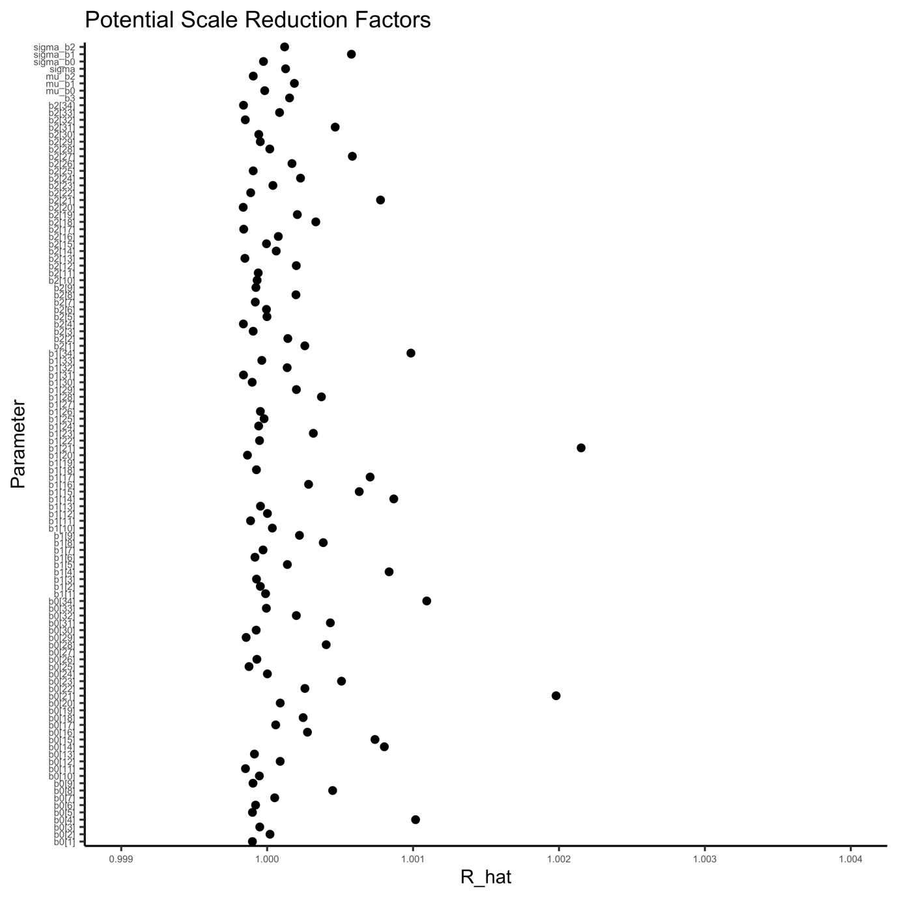

Fig. S28. Potential scale reduction factor ($\hat{R}$) for the metabolic rate model. This factor is based on the comparison of between and within-chain variation for the same parameter. A value close to one implies chains converged to the same distribution. The index of the parameter corresponds to species.

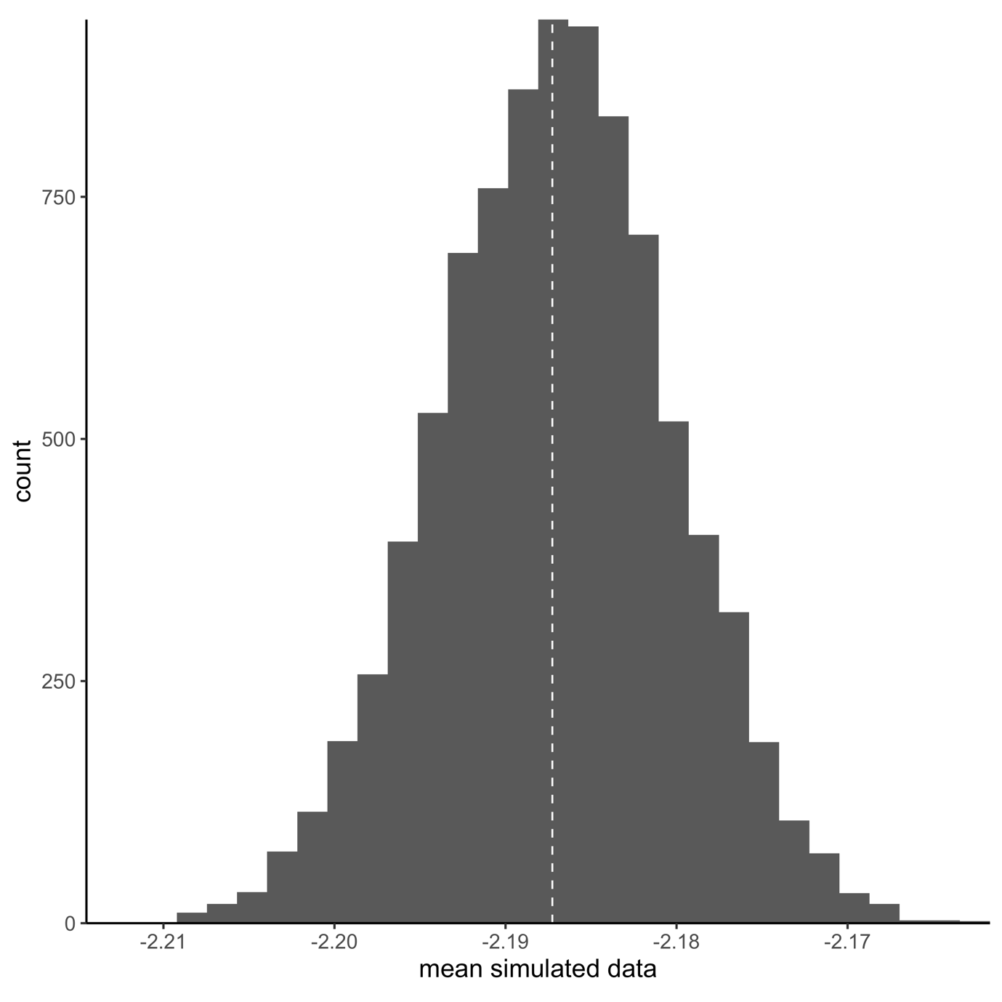

Fig. S29. Model fit (A=mean and B=coefficient of variation) for the model of metabolic rate at temperatures below temperature optima. Vertical lines correspond to mean in data and histogram depicts each posterior mean. Fit is evaluated by simulating data from the likelihood (at each iteration of the MCMC chain), to compare how well it matches the original data. Each simulated datum is assigned a 0 or 1 if it is below or above the mean data point. The number in the plot corresponds to the mean of the vector of 0’s and 1’s.

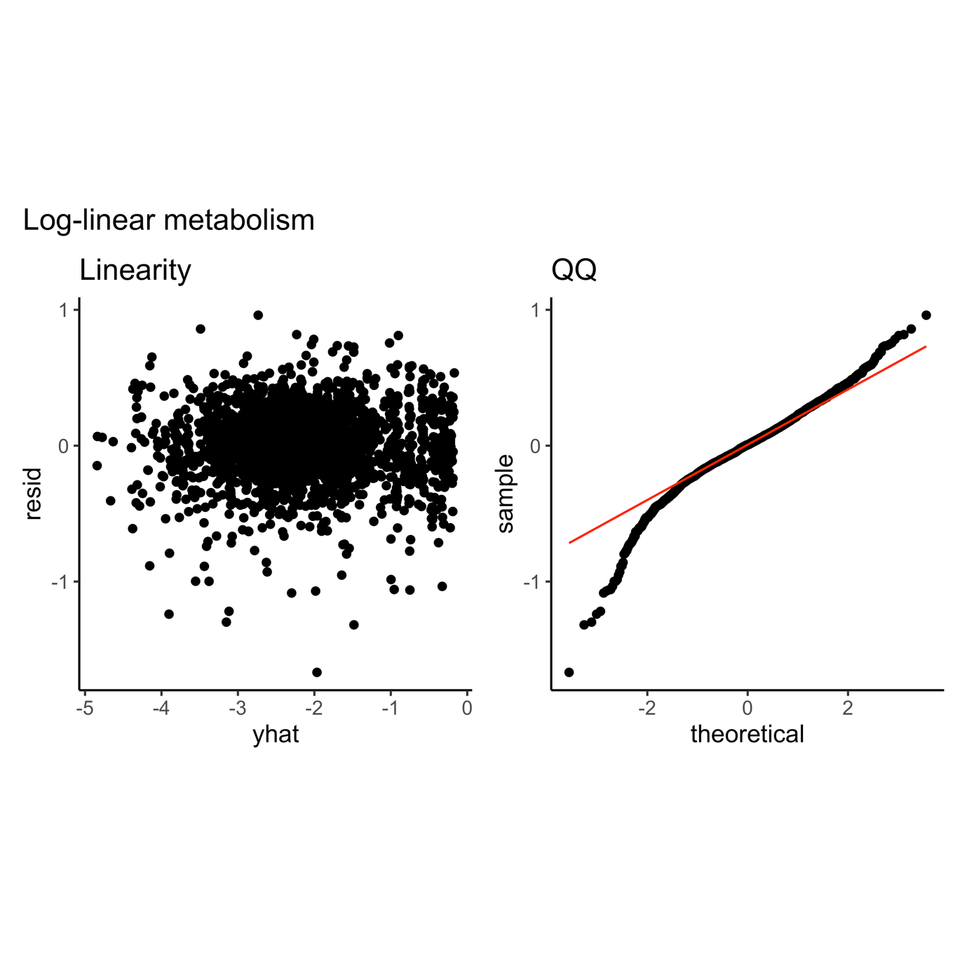

Fig. S33.

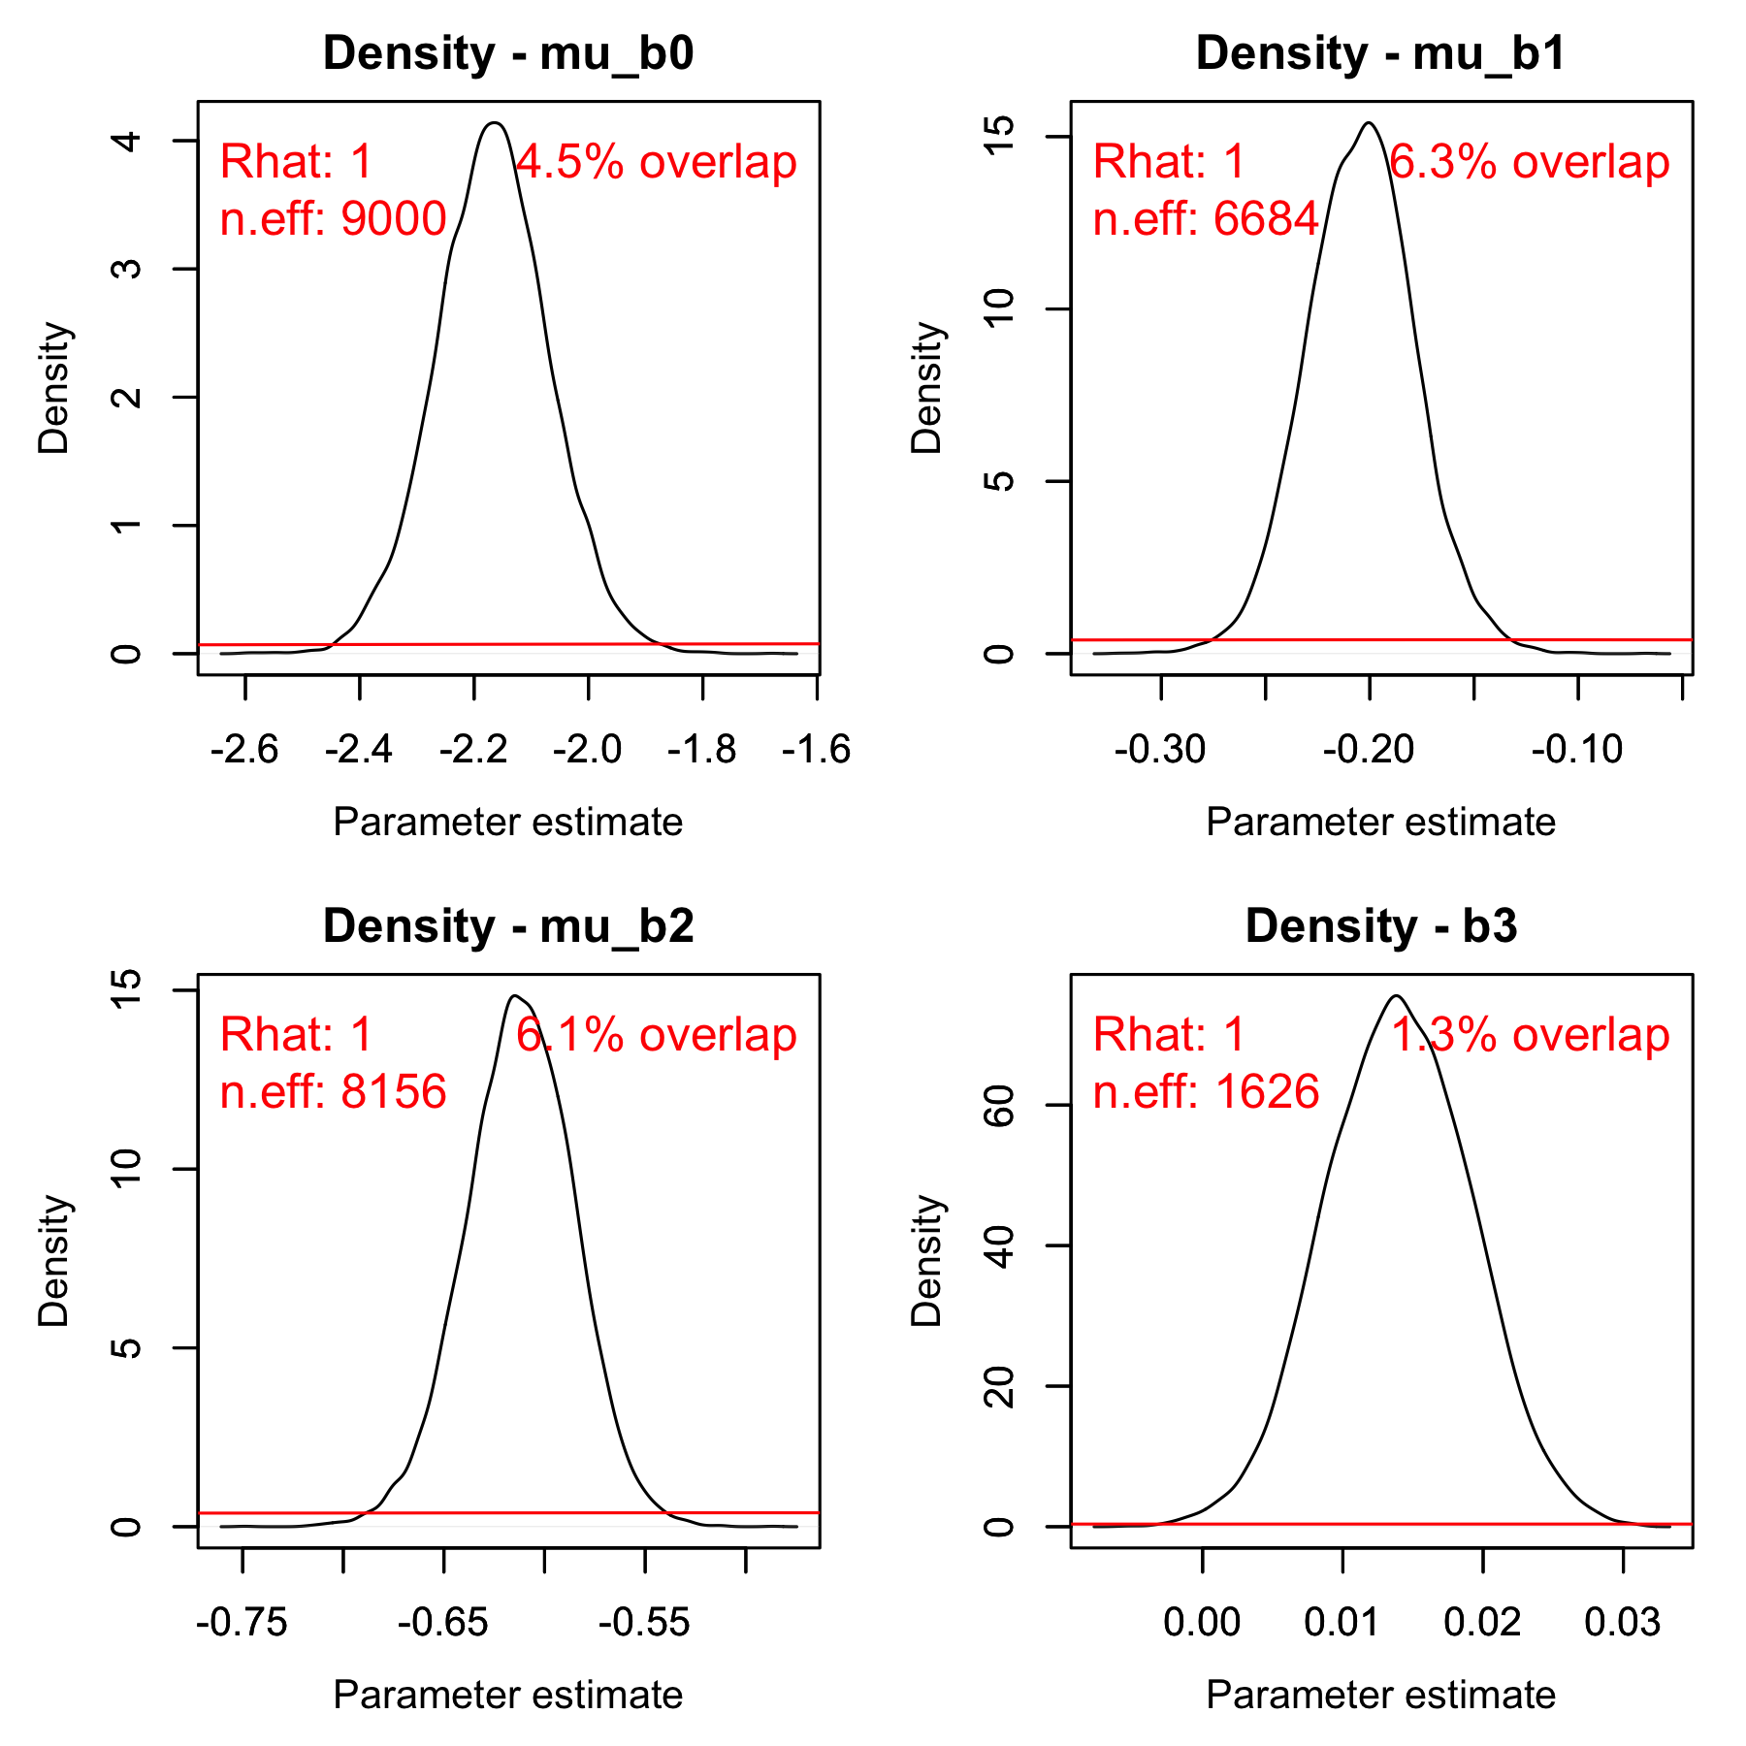

Fig. S30. Posterior (black) and prior distribution (red) for the global parameters in the model for metabolic rate, including their % overlap, effective sample size and $\hat{R}$ (rounded).

## *Optimum growth temperature*

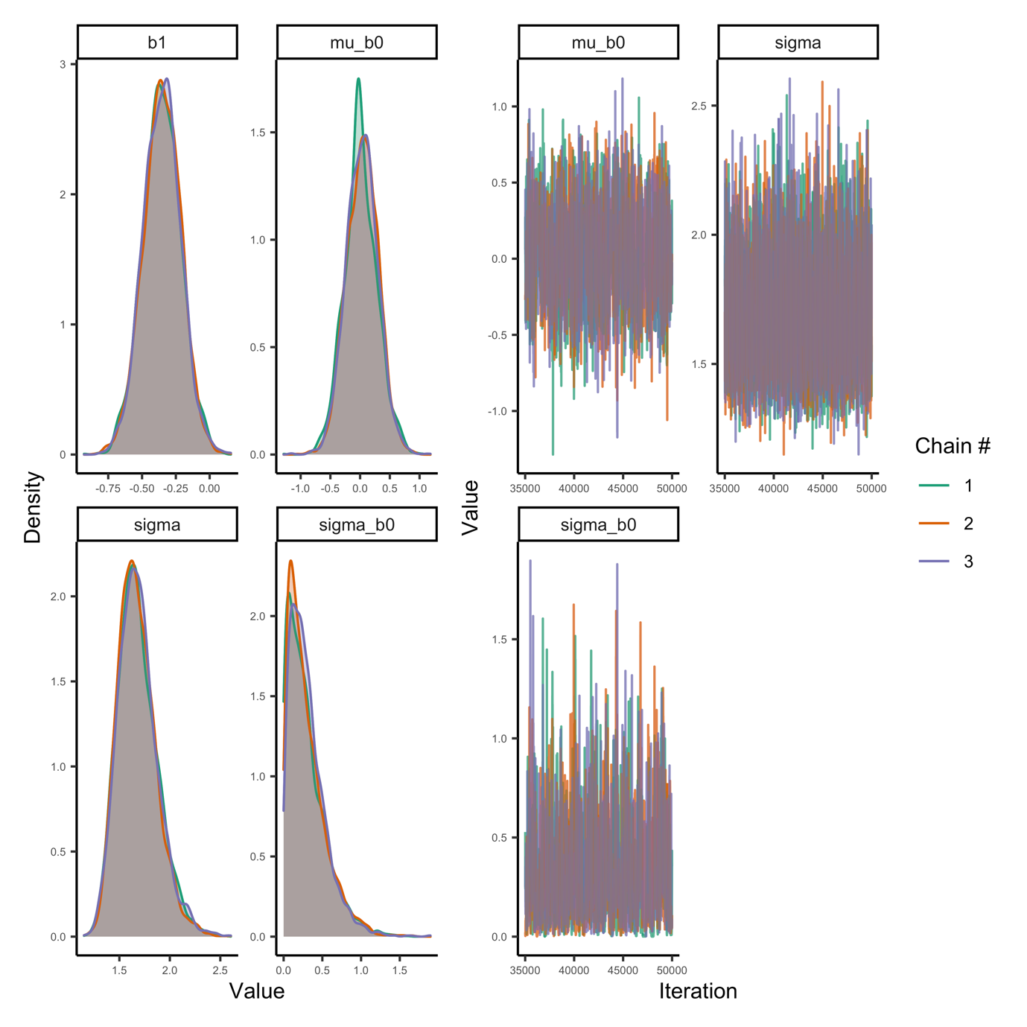

Fig. S31. Posterior densities and trace plots for evaluation of chain convergence (by chain, indicated by colour), for the global-level parameters for the $T_{opt}$ model.

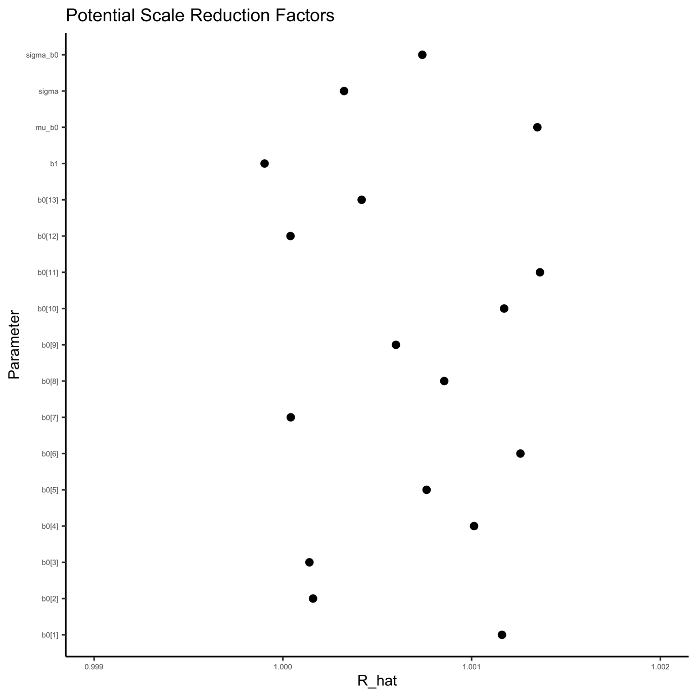

Fig. S32. Potential scale reduction factor ($\hat{R}$) for the $T_{opt}$ model. This factor is based on the comparison of between and within-chain variation for the same parameter. A value close to one implies chains converged to the same distribution. The index of the parameter corresponds to species.

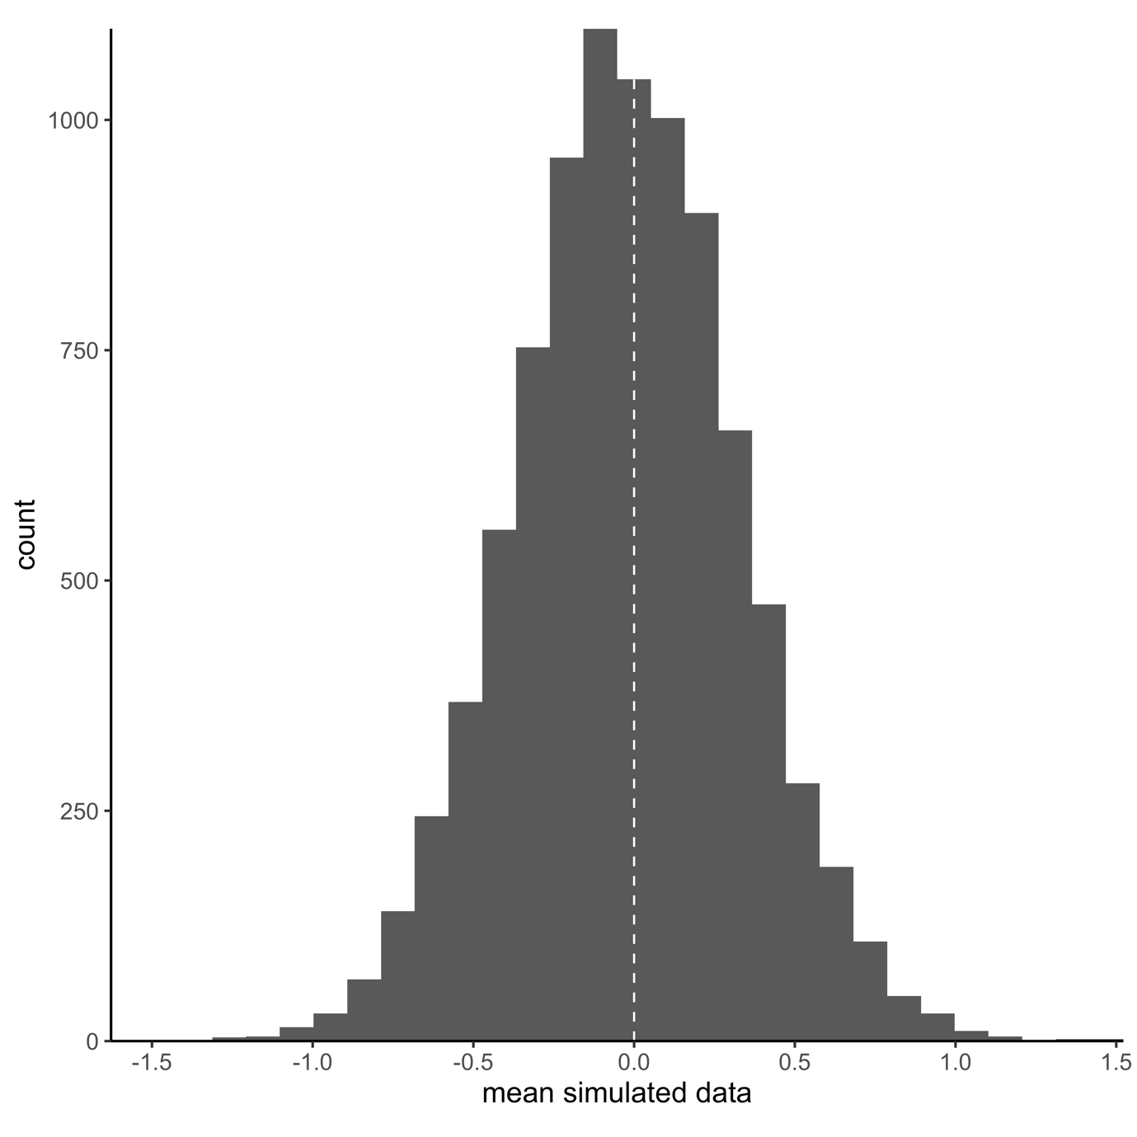

Fig. S33. Model fit (mean) for the $T_{opt}$-model. Vertical line corresponds to mean in data and histogram depicts each posterior mean. Fit is evaluated by simulating data from the likelihood (at each iteration of the MCMC chain), to compare how well it matches the original data. Each simulated datum is assigned a 0 or 1 if it is below or above the mean data point. The number in the plot corresponds to the mean of the vector of 0’s and 1’s.

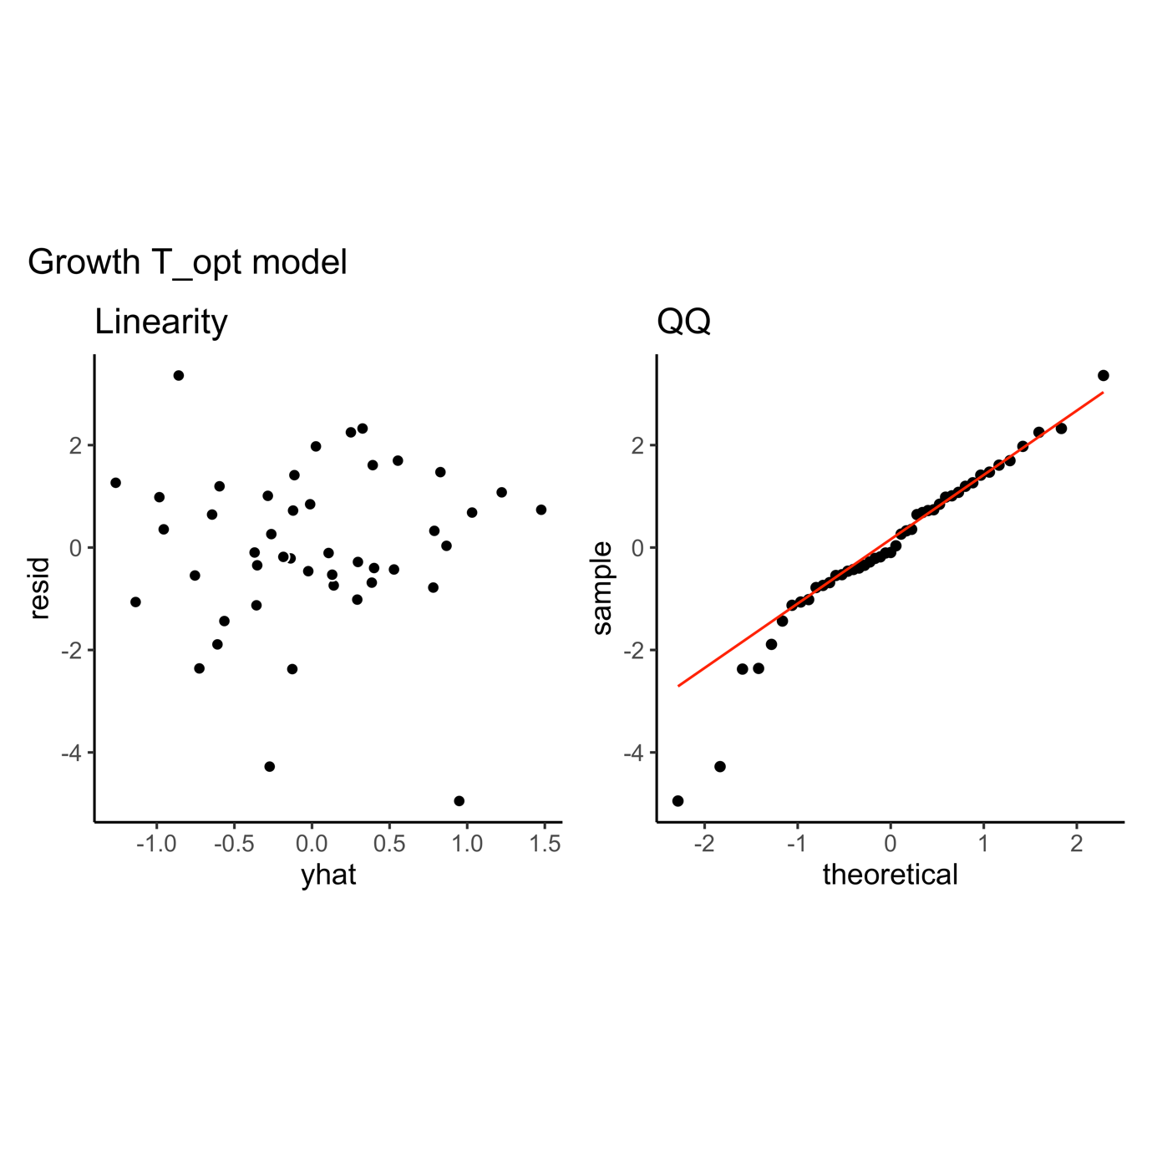

Fig. S33.

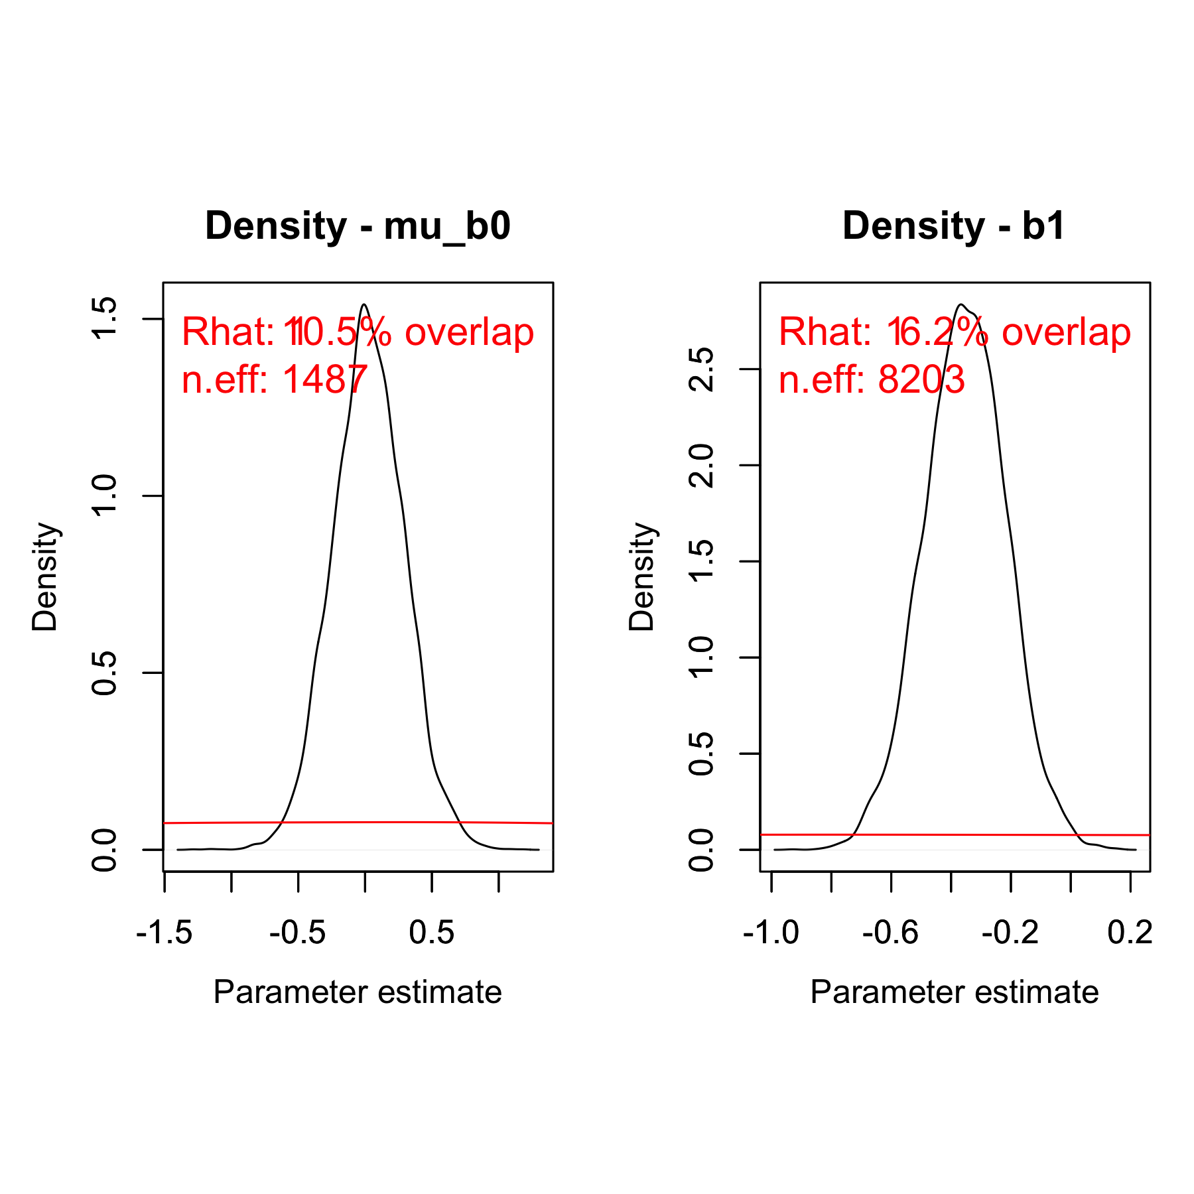

Fig. S34. Posterior (black) and prior distribution (red) for the global parameters in the model for $T_{opt}$, including their % overlap, effective sample size and $\hat{R}$ (rounded).

# References

Brett, J.R., Shelbourn, J.E. & Shoop, C.T. (1969). Growth Rate and Body Composition of Fingerling Sockeye Salmon, Oncorhynchus nerka, in relation to Temperature and Ration Size. *J. Fish. Res. Bd. Can.*, 26, 2363–2394.

Deslauriers, D., Chipps, S.R., Breck, J.E., Rice, J.A. & Madenjian, C.P. (2017). Fish Bioenergetics 4.0: An R-Based Modeling Application. *Fisheries*, 42, 586–596.

Froese, R. & Pauly, D. (2016). *Editors. FishBase*. World Wide Web electronic publication. www.fishbase.org, (10/2016).

Froese, R., Thorson, J.T. & Reyes, R.B. (2014). A Bayesian approach for estimating length‐weight relationships in fishes. *Journal of Applied Ichthyology*, 30, 78–85.

Rohatgi, A. (2012). *WebPlotDigitalizer: HTML5 based online tool to extract numerical data from plot images. Version 4.1. [WWW document] URL https://automeris.io/WebPlotDigitizer (accessed on January 2019).*